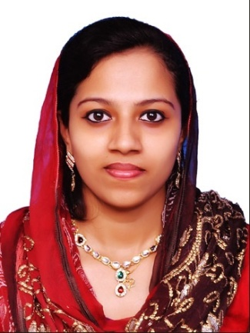  Afna.331988@2freemail.com  Afna | OBJECTIVE  Obtain an employment opportunity with a well reputed establishment where my creative talents and commitment to excellence can be applied and enhance. Being a pharmacist my prime objective is to achieve good relation between the patients and to inform them about the efficient use of drugs and its side effects.  ASSETS  Personal Summary  - Strong passion for healthcare.  - Able to advise patients on medication brands, medication storage, medical equipment and health-care supplies.  - Dedicated to providing quality patient care and fast and accurate medication dispensing. Currently looking for a suitable pharmacist vacancy in a modern well equipped pharmacy.  Supervising  - Ability to manage through others.  - Ability to work well with all levels of the organization.  - Superb coaching and mentoring skills.  - Prioritizing important tasks and ensuring they get done first.  - Excellent oral and written communication skills.  - Ability to follow and comprehend complex instructions, short correspondence, and memos.  - Able to quickly identify problems.  - Proficient with MS Office and various other forms of technology.  - Improving product quality and customer communications.  Areas of Expertise  - Keeping up to date with developments in the pharmaceutical industry.  - Ability in participating in clinical pharmaceutical research.  - Able to provide quality face to face customer interaction.  - A thorough understanding of various drugs and how they react in humans and with each other.  - Ability in Pharmaceutical Operations  - Ability in Prescription Dispensing/Compounding  - Customer/Patient Relationship Management  - Inventory Control  - Patient Counseling
Languages known  English Fluent  Hindi Fluent  Urdu Fluent  Tamil Fluent  Malayalam Fluent  Arabic Read & Write  Personal Details  Gender : female  Age : 30yrs  DOB : 27/06/1985  Marital Status : married  Nationality : INDIAN | ACADEMIC QUALIFICATION  - DHA  Have passed the DHA Exam and valid eligibility ID.  - YEAR 2004-2008  S.A. Raja Pharmacy college –Nagercoil,Tamil Nadu India – B Pharm (Bachelors in Pharmacy)  - YEAR 2000-2002  Saraswathy Vidyalaya – Kerala, India – Higher secondary  Obtained 76% in the Higher Secondary Examination  Vattiyoorkavu Pharmacy (2012- 2016)  - Responsible for the day to day running of the Pharmacy.  - Accurately dispensing drugs to patients according to a doctors prescription.  - Checking prescriptions for errors & making sure they are appropriate for patients.  - Measuring, packaging, labeling and recording medications issued to patients.  - Instructing patients on how to use medications, possible side effects and storage.  - Answering questions from patients and staff about medicines.  - Ensuring the accuracy of all prescriptions, products and services supplied.  - Managing and resolving complaints.  - Able to trains and supervise Pharmacy Assistants.  - Communicating with customers/patients sympathetically and supportively.  - Maintaining pharmaceutical stock, creating inventories and ordering more drugs.

TECHNICAL SKILLS

- Software: MS Office (Word, Excel, Outlook, Access, CRM, E-serve, Du-verse); Email (Microsoft Exchange, Lotus Notes Mail)
- Platforms: Windows Vista; Windows XP; Windows 2007, Server 2008
- Proficient in office productivity tools and excellent knowledge of internet for information gathering and communication.

Hobbies & Interests

- Watching social movies
- Researching about Medicines,
- Writing
- Listening to Music
- Socializing
- Dancing
- Singing
- Reading

Declaration

I, hereby solemnly declare that all the above furnished details are true to the best of my knowledge, to tell you more about myself and my credentials and request you to give me privilege of having an interview with you.

I conclude with my sincere and hardworking effort to serve you, with thanks.

Should my qualifications merit your consideration, I assure you of a prompt
Reply and thanking you in anticipations.

