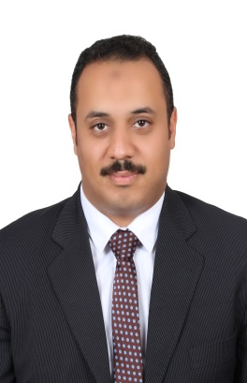
Mohamed
Mohamed.331996@2freemail.com

Snapshot: highly qualified senior finance management accountant professional with 16 years of experience across diverse organizations. Currently functioning as senior financial analyst AND HAVE CMA CERTIFICATE NO AND ORACLE CERTIFIED PROFESSINAL, seeking challenging senior managerial accounting with a reputed organization.
Core competencies
- Management accounting.
- Financial reporting
- Budgeting, financial analysis and ratios
- Strategic & business planning
- ERP systems
- Cost accounting
- Variance analysis.
- Capital investment.
Professional Details

Minya drinking water & waste water Company
From 20-08-2005 till now
Senior financial analyst
Responsibilities:
- Make performance indicator annually or quarterly.
- Make planning budget annually.
- Make capital planning and capital budgets.
- Make costs analysis and analyze the variance versus budget.
- Analyze financial statements (financial position, income statement, cash flow statement, retained earnings statement, the statement of shareholders equity).
- Make cash budget.
- Make variance analyses between budget and actual.
- Make internal control about executable budget to obtaining the objectives.
- Analyze the risks (inherent, business risks) and make risk management.
- Participate in study of alter the tariffs of water &waste water activities.

Mansour Company for trading &distribution of foods
From 1/2/2001 to 31/1/2008
Accounting manager

Responsibilities:
- Records and Control customers’ accounts
- Record the bank accounts and make bank reconciliation
- Make financial statements
- Control cash inflows &outflows
- Make cash budget &operational budget

Mohamed Ahmed soliman office
For financial consulting’s &tax experience
From 1/07/2000 - 31/1/2001
Junior auditor
Responsibilities:
- review organization’s accounts
- reconciliation their accounts
- reconciliation the organization’s financial statements
- prepare report about the fairness of the financial statements
Credentials

Academic:
Bachelor of commerce, major accounting (south valley university, sohag branch 2000)
Certifications:
- Cma (certified management accountant from ima organization April 2016
- Ocp (oracle certified professional (version 9i) 27-06- 2005
- Icdl (international computer driving license ) 31-10-2010
- Mini MBA FROM USAID under their project with Egyptian water governmental sector

Professional affiliation

Member of institute of management accountants of America
Member of oracle company training center
Personal information

Date of birth : 01-09-1979
Language known: Arabic & English
Nationality : Egyptian

Projects

I participated in:
- Egypt water and wastewater sector support program(WWSSP) funded by USAID
Participated as a member of team in:
- Project business Plan 2010-2015
- Work on the establishment of a database program Monitoring, Analysis, and Reporting System (MARS)in water and wastewater sector
- Work on the establishment of a database program to prepare future five years budget.
- I got a certificate of completion of professional development program from chemonics international consultant in Egypt in June 2013.

- Egypt wastewater decision support system (WWDSS) funded by (Deutsche Gesellschaft für Internationale Zusammenarbeit (GIZ)) AS German aid
Participated as a member of team in:
Establishment of planning departments for wastewater financial and technical plans from 2011 to 2016.
- Participated as a member of team in:
Update water and wastewater Tariff with Egyptian water and wastewater regulatory agency (EWRA)

