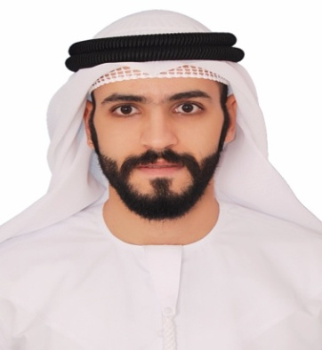
Elmostafa
Email: elmostafa.332033@2freemail.com

Summary:
Teller with an outstanding background in customer service, sales and banking. Addresses all questions and concerns with customer satisfaction in mind.

Skills:
*Cash handling *Expertise Math *Aptitude Rapid data entry skills
* Multilingual in Arabic, English and Hindi *Calm under pressure
*Strong written and verbal communication skills *Training development aptitude
*Creative problem solver *Public relations

Professional Experience:
Teller
UAE EXCHANGE CENTER LLC (Abu Dhabi, UAE) JAN/2014 to DEC/2016
*Perform cash handling, customer service, balance drawer.
*Explained and documented for clients the types of services to be provided, and the responsibilities to be taken.
*Exceeded monthly sales goals by 30%.
*Handled various accounting transactions.
*Executed wire transfers, stop payments and account transfers.
*Processed exchange and foreign currency.
*Answered telephone inquiries on banking products.
*Maintained friendly and professional customer interactions.

Sales executive
Calcados (Cairo, Egypt) NOV/2011 TO JUNE/2013
*Greeted customers in a timely fashion, whilst quickly determining their needs.
*Documented all customer inquiries and comments thoroughly and quickly.
*Placed special merchandise orders for customers.
*Successfully acquired an average of 60 new customers per month, generating a 10% growth in revenue.

Customer service representative
Nile international (Cairo, Egypt) OCT/2010 TO NOV/2011
*Described product to customers and accurately explained details and care of merchandise.
*Provided an elevated customer experience to generate a loyal clientele.
*Effectively communicated with and supported sales, marketing and administrative teams on a daily basis.
*Created strategies to develop and expand sales of products to existing customer which resulted in a 95% increase in annual revenue.

Education:
Bachelor degree in social work .October 2011 The Higher Institute Of Social Work
*Human Services Coursework
*Persuade civil training during graduation.

Certificates and Training:
*Business communication and leadership course.
*Anti money laundering training.
*Marketing and sales training.
*customer service training.
*Allied products and services training.
*Arab business corridor training.

Personal Information:
Date of birth : 14 September 1988
Nationality : Egyptian
Visa status : Employment visa
Marital status : Single
Driving license : Valid UAE driving license

