CURRICULUM VITAE

Personal Information
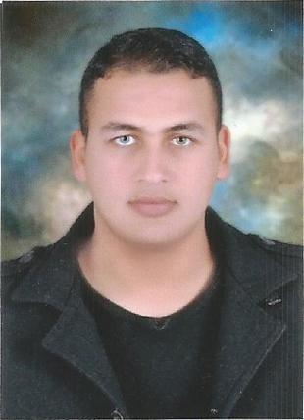Name: Osama
Address: Dubai,UAE.
Date of birth: September 1st, 1991.
Marital Status: Single. Military service: Performed. Nationality: Egyptian.
Visa Type: Visit Visa (valid till 8/2/2017).
Email :- Osama.332068@2freemail.com

Education

From 2008 to 2012 Bachelor from Mansoura University
“Faculty of Computer Science and Information Systems”| Information Systems Department" Evaluation (Excellent with honour, Ranked (fourth), 86.74%) Graduation Project (Smart Home With grade excellent)
Basic Technical Skills
- Networking: CCNA, MCSA (Windows Server 2012).

Additional Technical Skills
- Programming: Java (windows application), C# (windows application).
- Database: SQL.
- Other: VMware, Have a good background in web development and design, Good Understanding of Database designing concepts, Data Structure, UML, System Analysis and design, MS Office.

Personal Skills
- Languages: Arabic (Native), English (Very Good)
- Soft Skills: Very good communicator, excellent presenter.
- Other: Excellent Self learner, Knowledge Seeker, Team Player, Work under pressure, Time management skills.

Experience:
- From 2012 to 2013: Trainee at New Horizons computer learning center (SQL, JAVA, C#).
- From April 2013 to October 2015: Reserved officer at Egyptian Armed forces (Electronic Warfare).
- From October 2015 to October 2016: IT engineer at ONE LAB Training and Network solutions (CCNA, MCSA).

