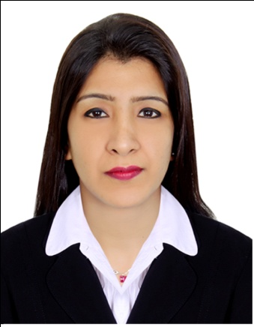  LAXMI  LAXMI.332103@2freemail.com  Personal Details  DOB : 25- March -1991  Sex : Female  Marital Status : Married  Religion : Hindu  Nationality : Nepalese  Passport Details  Date of issue : 14 - 08 - 2016  Date of Expiry : 13 - 08 - 2026  Place of Issue : Kathmandu  Visa Status : Tourist Visa  Personal Strengths  - Self Confidence  - Quick Learner  - Good team Player  - Flexible  - Responsible  - Self motivated  - Honesty & Integrity  - Initiative  Linguistics  English : Fluent  Hindi : Fluent  Nepali : Native Speaker  Greek : Basic | CURRICULUM VITAE  OBJECTIVES:  I am looking for an opportunity, on a long-term basis, to be a part of an esteemed professional and dynamic growth oriented organization which provides me an opportunity to apply my interpersonal skills, my talents and professional experience to achieve the organization’s objectives whilst allowing me to grow within it.  WORK EXPERIENCE:  CASHIER / PRO  West Zone Fresh Supermarket LLC  27 – Aug – 2014 to 27 - Aug - 2016  CASHIER  Duties & Responsibilities:  - Handle cash transactions with customers  - Scan goods and collect payments  - Issue receipts, refunds, change  - Resolve customer complaints, guide them and provide relevant information  - Greet customers when entering or leaving establishments  - Maintain clean and tidy checkout areas  - Keep reports of transactions  - Bag, box or wrap packages  - Pleasantly deal with customers to ensure satisfaction  PRO  Duties & Responsibilities:  - Listen to customers’ questions and concerns, and provide answer  or response on calls  - Answer customers queries regarding products and delivery.  - Prepare and deliver the items according to the customers’ orders.  - Maintaining interpersonal relationships with the public, especially customers.  - Ascertain the amount of cash in drawer at the start of every shift.  - Assist customers by providing information and resolving their complaints.  - Supervise other staff and provide on the job training as a when required by management  - Providing training & assistance to new joined cashier.  - Generate cash, transaction and cards reports.  - Balance cash registers at the end of each shift
WAITRESS

- Restaurant Cyprus 2009 to 2013
CASHIER

- Burger King - 2009

TEACHER

- Bal Vikas Secondary School, 1997 - 1999

- Sampurna Secondary School , 1999 - 2009

EDUCATION:

  - SCHOOL LEAVING CERTIFICATE 1996
Lalitpur Secondary Boarding School

  - PROFICIENCY CERTIFICATE LEVEL 1999
Padma Kanya College

  - BACHELOR IN ARTS ( BA ) 2006
Padma Kanya College

COMPUTER KNOWLEDGE:

- Basic ( Microsoft , Excel , Power point..)

HOBBIES

- Shopaholic person & Socializing with new people
- Travelling
- Listening Music

PROFESSIONAL SKILL HIGHLIGHTS:

- Excellent communication, presentation & problem solving skills.
- Highly Adaptable to multicultural teams and highly organized.
- Creative and aggressive self-starter with integrative thinking skills and thrive for uniqueness.
- Easy grasping innovations in technologies.

DECLARATION

I hereby declare that the above information is true to the best of my knowledge.

