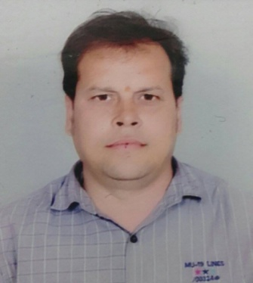
Chandan
Email: chandan.332106@2freemail.com

Summary: Having a vast of working experience as an Operation Assistant, Branch In-charge, Supervisor In charge in different fields.

EDUCATIONAL BACKGROUND

- 12TH ( CO MMERCE) Dumdum Airport Hindi High school, Calcutta (West Bengal Higher Secondary Board)

KNOWLEDGE AND SKILLS:
- Computer Literate (Microsoft word and Excel).
- Language Spoken: Hindi, Bengali, and English.

Job Experience:

2008 – 2016 (Supervision In-charge) Hariom Construction Real Estate Company. Indore, India

Job Responsibility

- Supervising staff members and groundkeeper.
- Negotiating and ensuring every material needed in the site are in order and properly delivered.

2007- 2008 (Branch In -charge) Expresses IT Worldwide Logistics.
Calcutta, India

Job Responsibility
- Responsible for proper distribution, coordination, warehousing, stock control, and monitoring the flow of goods.
- Ensuring the right products are delivered to the right location time and at a good cost.

2005-2006 (Housekeeping In charge) Ashish International, (Bhilai CG), India

Job Responsibility

- Assuring the highest quality degree of guest care is maintained at all times.
- Planning, organizing, and developing the overall housekeeping department.

2001-2004 (Operation Assistant) Patel Air Freight (A division of Patel on Board Couriers LTD) Calcutta, India
Job Responsibility

- Providing administrative support and clerical tasks that aid in daily business operation.
- Reporting, organizing and compile information related to business assigned by the superior.
- Airport Cargo material or shipment releasing and clearance of goods.

