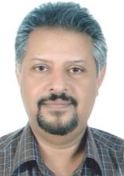
HOSAM HOSAM.332164@2freemail.com

SENIOR BUSINESS DEVELOPMENT / MANAGER PROFESSIONAL
Seeking positions as Business Manager – Sales & Operations
Dynamic in orchestration of multimillion-dollar business start-ups, turnaround, strategic planning, market entry strategies, competitor analysis and growth ventures
Geographical Preference: Riyadh - KSA / UAE & Other GCC Countries
Industry Preference: Building Material, Real Estate, Construction or General Engineering

PROFILE ABRIDGEMENT

- Profit-Driven Senior Sales Leader with cultural acumen & multimillion-dollar record throughout Saudi Arabia (Central & Eastern Provinces); creating near-constant revenue through perpetual relationship cultivation among global corporations
- Currently working with ROLACO, Saudi Arabia as Regional Manager – Central & Eastern Regions
- C-suite relationship builder instrumental in start-up and global expansion & business growth; spearheading overall business operations with turnover worth 30 million and more
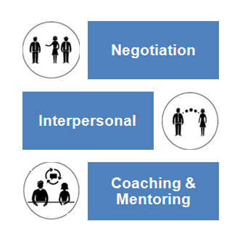
- Over 25 years of experience; primary sales driver, creating high-ROI relationships against well-established, global competitors and positioning and generating business with comprehensive knowledge in Construction, Building Material, Equipment & Automotive, Real Estate Development, Facility Management, Construction Equipment Rental, Steel Fabrication & Scaffolding, Power Generators & Lifting Equipment domains.
- Award Winner Manager for attaining the business growth and sales expansion in Saudi Arabia; career-long history of success in accelerating sales through personal and onsite contact
- Deft in turning around underperforming business and enhancing the value of operating business units through process improvements focused on sales & best practice identification and implementation
- Capability to develop systems, policies, and procedures and turn them into life and action within the organization. Changing culture through training and development is one of the key strengths
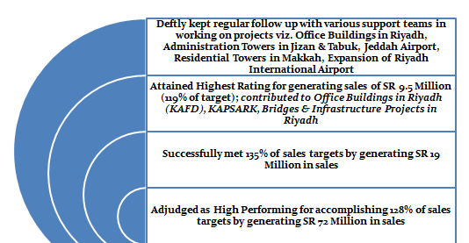
- Energetic leader known for ability to envision and create successful outcomes in complex and multicultural environment
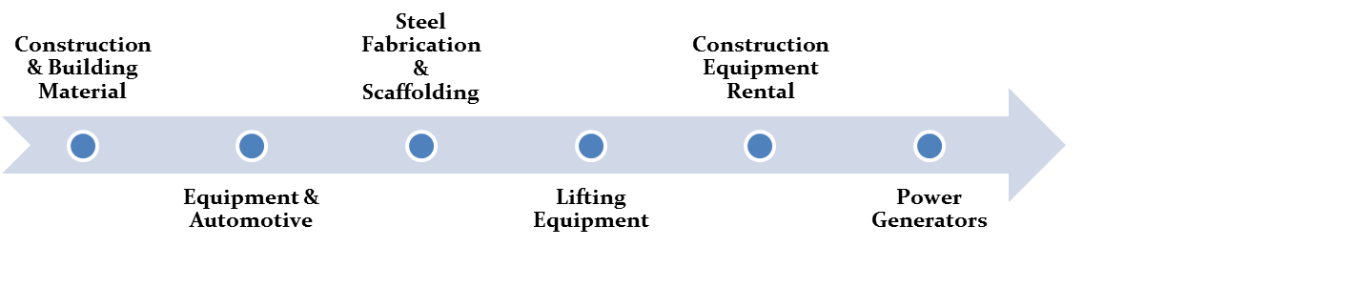
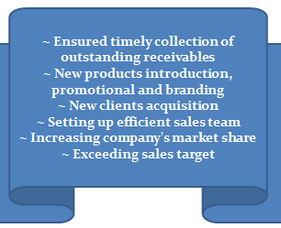
CAREER CHRONOLOGY & ACHIEVEMENTS
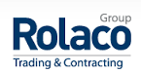
Jul’13-Dec’16: ROLACO, Saudi Arabia as Regional Manager – Central & Eastern Regions

Roles & Responsibilities: Managing complete business operations with accountability for profitability for local commercial & industrial group covering Construction, Building Material, Equipment & Automotive, Real Estate Development, Facility Management, Equipment Rental, Steel Fabrication & Scaffolding, Electrical& Power, Agricultural, Hospitality, Tourism, Shipping, Acoustics & Lights domains; forecasting monthly/ annual sales targets & executing them in given time frame by organisational planning.

- Conceptualized & effectuated innovative strategies for effectively launching or stabilizing operations in compliance to global standards of quality, service and customer satisfaction; provided operational support aimed at augmenting retail showroom sales, developing the company's newest office building project in Riyadh, leasing of office space, providing facility management services (civil, electromechanical, landscaping & security).
- Partnered with regional teams in accomplishing business & revenue targets by implementing region specific marketing plans; implementing sales programs/strategies to improve the product awareness in markets by brand building and market development efforts
- Deftly evaluated inventory levels across various points of sale and followed up with vendors / suppliers in maintaining delivery schedules based on reorder levels
- Essayed a stellar role in creating as well as presenting detailed reports & presentations highlighting organizational performance and potential performance bottlenecks to the board members to enable effective decision making
Apr’11-Jun’13: UTPCO, Riyadh, Saudi Arabia as Executive Manager

Strategized the long term business directions of the region to ensure maximum profitability in line with organisational objectives, Coordinated budgets, forecasts and reports & accordingly effectuated business plans to attain maximum sales and optimum revenue. Enhanced market penetration for a UAE based organization dealing in building materials, real estate and property development & facility management across the target market in the KSA.
- Successfully:
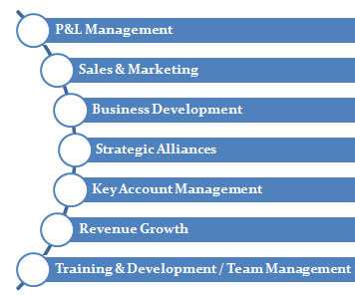
  - Restructured business strategies based on collated market intelligence on competition and other market trends for accomplishing business targets of SAR 23 Million by supplying building material to prestigious projects and managing existing facilities such as polyclinics, warehouses, furnished apartments, and providing civil, electrical, mechanical, maintenance, safety & security services.
  - Collated and maintained updated market & customer information to obtain a clear understanding of customer’s business needs and requirements.
  - Laid the foundation for the company's first commercial real estate project in Riyadh, consisting of commercial shops & offices.
- Nurtured healthy business relationship with existing clients & prospects for identifying as well as developing new business opportunities using consultative sales strategies
- Efficiently & effectively provided guidance to the sales team in closing critical business deals with potential revenue impact for accomplishing business targets
- Kept regular follow up with various support teams in working on projects encompassing Office Buildings in Riyadh, Administration Towers in Jizan & Tabuk, Jeddah Airport, Residential Towers in Makkah, Expansion of Riyadh International Airport in compliance to project SLA parameters
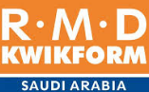
Feb’10-Apr’11: RMD (British Company – Formwork), Riyadh, Saudi Arabia as Sales Manager

Conceptualised & implemented innovative plans for accomplishment of pre-designated targets from the assigned territories, Forecasted monthly/annual sales targets and executed them in a given time frame thereby enhancing existing clientele. Identified prospective clients by extensive study of market trends and demand & supply analysis and mapped requirements adding to business growth. Partnered with various support teams in enhancing market penetration by efficiently managing sales & marketing operations across the Central Province.
- Dexterously represented company in various building material exhibitions for enhancing organizational brand awareness and business from the target market segment
- Pivotal in rendering qualitative presentations highlighting organizational / product capabilities to enhance brand awareness during exhibitions and promotional campaigns
- Bagged High Rating for generating sales of SR 9.5 Million (119% of target); contributed to Office Buildings in Riyadh (KAFD), KAPSARK, Bridges & Infrastructure Projects in Riyadh
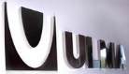
Jan’09-Jan’10: ULMA-ATTIEH CO.,(Spanish JV Co. - Formwork) Jeddah, Saudi Arabia as Country Sales Manager

Drove business growth through identification & penetration of new market segments for attainment of targets with a view to optimize revenue. Tapped areas of growth & proposing new projects to the management to capitalize on such opportunities through market intelligence activities. Launched new products taking care of promotional aspects & performance requirements or planning marketing activities to launch new products. Took care of administrative functions encompassing sales & marketing & staff performance to ensure seamless operations.
- Holds the distinction of catering to major projects viz. Princess Noura University in Riyadh, Al-Rajhi Tamkeen Tower, Jabal Omar Project in Makkah in compliance to project delivery schedules and other SLA parameters
- Instrumental in accomplishing 135% of sales targets by generating SR 19 Million in sales

Jan’08-Dec’08: Unisteel Co., (Part of Al-Fozan Commercial Group) Riyadh, Saudi Arabia as Commercial Manager

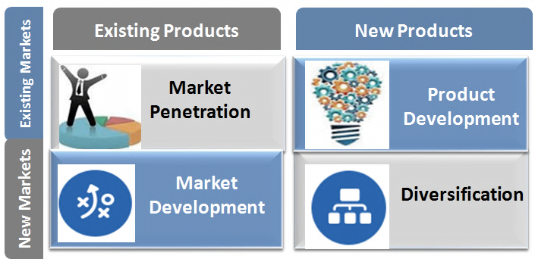
Oversaw wide gamut of sales & marketing tasks for branches & warehouses across Saudi Arabia aimed at enhancing market penetration for the newly set up company in Saudi Arabia. Looked after administrative aspects related to recruitment, selection & grooming of team members based on business as well as operational requirements.
- Played a vital role in realigning business strategies based on collated market intelligence on competition and other market trends to maximize coverage of the target market segment
- Deftly rendered commercial support for various projects like Office Buildings in Riyadh (KAFD), Princess Noura University, King Saud University in Riyadh, Al-Qasr housing Project, KAUST, Hospital Projects &Residential Towers
- Adjudged as High Performing for accomplishing 128% of sales targets by generating SR 72 Million in sales
PRIOR EMPLOYMENT DETAILS

Jan’96-Dec’07: Doka Formwork Technology (Austrian Co. – Formwork), Jeddah & Riyadh – KSA
Last designated as Branch Manager - Central Province
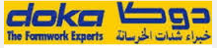
Growth Path:
Jan’96-Dec’98 Sales Engineer, Western Province
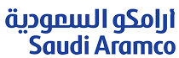
Jan’99-Dec’00 Senior Sales Engineer, Western Province
Jan’01-Dec’03 Assistant Sales Manager, Western Province
Jan’04-Dec’05 Area Sales Manager, Western Province
Jan’06-Dec’07 Branch Manager - Central Province
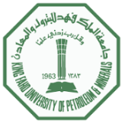
Nov’94-Jan’96: Saudi Aramco, Dhahran, Saudi Arabia as Site Engineer

Jan’91-Sep’94: KFUPM, Dhahran, Saudi Arabia as Lecturer

SKILL ENHANCEMENTS

- Developing People
- Professional Sales Training Course
- Cloud Computing for Sales Professionals
- Product Promotion Workshop
- Professional Sales Training Course II
- ARAMCO Technical Specs & Procedures Training
- Sales Training Seminar for Sales Executives
- ARAMCO Technical Software Training

PROFESSIONAL AFFILIATIONS

- Member - Saudi Council of Engineers, 2012
- Member - Jordanian Engineers Association, 1995

SCHOLASTICS

Masters in Construction Engineering & Management in 1991
King Fahd University for Petroleum & Minerals

Bachelor of Science, Architectural Engineering in 1988
King Fahd University for Petroleum & Minerals

Date of Birth: 20th December, 1964 ~ Linguistic Abilities: English and Arabic ~ Nationality: Jordanian

