Jenan
Jenan.332171@2freemail.com
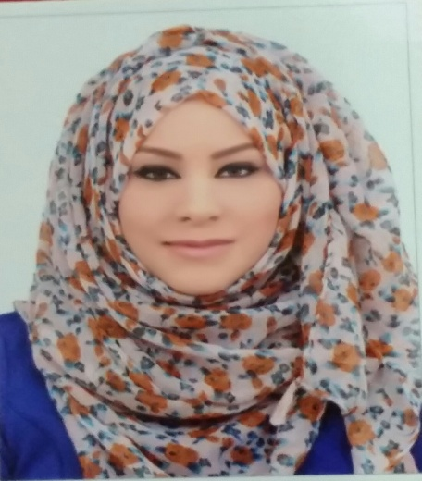
Personal details:
Date of birth: 5th -June-1993
Nationality: Jordanian.
Marital status: Single
Address: Al Nahda - Al Sharjah – United Arab Emirates .
Valid UAE driving license and Personal car are available .
Objectives: To work in a competitive sales environment in which focused application of sales skills will achieve success and even exceed the organization sales goals and objectives .
Skills and abilities:
- Excellent computer skills.
- Arabic mother tongue and fluent in English .
- Excellent communication and social skills.
- Good working ethics and moral standards.
- Quick learner .
- Good organizational and time management skills.
- Strategically thinking (priorities / multi-tasks).
Education:
Sharjah University : fresh graduate pharmacy BSC degree , Sharjah- UAE . 2012-2016
Experience :Training :
- Months of training in different Places ,2016,:
- 1month in New Palestine pharmacy
(Community pharmacy)
- 1 month in the American hospital: (inpatient pharmacy).
- 1 month in Al -Baraha hospital: (outpatient / inpatient pharmacy).
- 1 month in Sharjah Health Center pharmacy.

