ABDULRAHMAN
ABDULRAHMAN.332178@2freemail.com
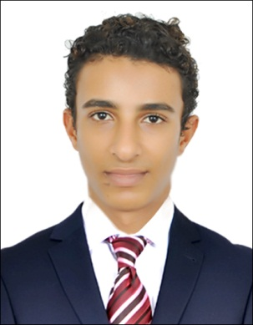

Personal information
Date of birth: 20 April Visa status: Residence
Nationality: Kenyan languages: English, Arabic & Swahili
Civil status: Single Religion: Muslim
Sex: Male
Objective: To use my valuable experience, ocean skills along with my leadership and language abilities to gain a challenging position with opportunity to advance. Very good communication skills, Dedicated to maintain a high quality of standards, colleague satisfaction. Work well under pressure and able to meet deadlines. Handle every task with a complete dedication.
EMPLOYMENT HISTORY
ATLANTIS THE PALM, Dubai. UAE
Lifeguard
- Provide a professional ocean skills at a level standard
- Provide safe surrounding our guests and as well as our colleague in need
- Direct guest interaction in a professional manner of which excellence our communication skills
- Maintain discipline and always punctual to strive for better success.
Equistar limited, Mombasa, Kenya. 2013 Nov – 2015 Nov
Sales and marketing officer;
- Manage retail staff and people working on the floor.
- Formulating pricing policies.
- Ensure the pricing is correct & determine daily coupons.
- Meet financial objectives by preparing an annual budget; schedules; expenditure; analyzing variances & initiating corrective actions.
- Attend trade shows to identify new products and services.
- Handle customer questions, complains and issues.

Safia bottled drinking water
Sales and marketing officer; 2016 Feb- 2016 Aug
- Help retail sales staff achieve sales targets.
- Handle customer questions, complain and issues.
- Maintain store’s cleanliness & health and safety measures.
- Monitor local competitors.
- Utilize information technology to record sales figures, for data analysis and forward planning
Academic Qualifications
Burhaniya Secondary School, secondary certificate (KCSE) 2009 Feb - 2013 Nov
Central Primary School, primary certificate (KCPE) 2000 JAN - 2009 Nov
Professional Qualifications
TIMES COMPUTER COLLEGE
- Basic computer packages.
- Intro to computers
- Window 2000/XP/VISTA/Windows7.
- Microsoft outlook Microsoft word
- Microsoft access.
Related coursework and interpersonal skills: Good communication skills, proven public relations, quick learner and can easily adapt to any situation efficiently, quality leader & strong competence.
Hobbies
- Swimming.
- Gymnasium.
- Football.
- Travelling & socializing.

