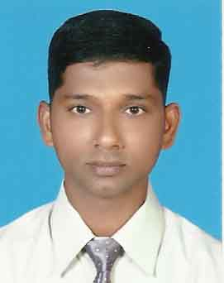
Mr. Ibrahim
To interview Ibrahim, send your company name, vacancy details with CV Reference No 1993080 to cvcontacts@gulfjobseekers.com

POSITION APPLYING FOR :SALES AND MARKETING EXECUTIVE & STORE KEEPER / SUPERVISOR

CAREER OBJECTIVE
Seeking challenging and responsible position in an enterprising organization where opportunities exist for knowledge enhancement and professional growth.

PERSONAL DETAILS

- Nationality : INDIAN
- Date of Birth : 25/12/1974
- Sex : Male
- Religion : Muslim
- Marital status : Married
- Languages Known : English, Hindi, Malayalam and Arabic

EDUCATIONAL QUALIFICATION

- Bachelor of commerce ( B.COM)

TECHNICAL QUALIFICATION

- Diploma in advanced software ( MS office)
- Internet and email.

WORK EXPERIENCE
- Since 2006 working in TAWAM HOSPITAL AL-AIN, U.A.E logistics section from June 2006 to July 2012 as a Store Keeper/Data Entry Clerk

SALES MARKETING
Working from August 2012 to October 2016 as a Sales and Marketing Executive.

STORE KEEPING
- Receiving store items(goods)from ware house

- Issued supplies as per order.
- Organize store items day by day.
- Updating delivery note in the system.
- Weekly once checking expiry items.
- End of the month physical counts (Inventory).
- Reported to store manager on a regular basis.
SUPERVISING
- In ware house every day receiving goods from the company.
- Every day entry delivery note in the system.
- Transfer supplies from ware house to central store as per order.
- Every month checking expiry items.
- Maintains inventory by conducting monthly physical counts.

DATA ENTRY
- Responsible in dispensing out-patient supplies.
- Handling patient history information system.
- Preparing dispensing issue vouchers.
- Entering of issued out-patients vouchers in the hospital’s materials control system oracle ( RS6000) and cerner
- Processing general office paper work.
- Working on cerner (distribution, issues, item enquiry etc)
- Oracle (move order ,view material transactions, employ self-service , updating patient issue voucher

Driving License

Having valid UAE Light Vehicle Licenses issued from U.A.E
Knowledge
Well versed knowledge about all roads in UAE Specially Alain, Abu Dhabi, Dubai and Northern Emirates.

DECLARATION

I hereby declare that the above information is true to the best of my knowledge and belief.
Ibrahim Kutty

Mr. Ibrahim
To interview Ibrahim, send your company name, vacancy details with CV Reference No 1993080 to cvcontacts@gulfjobseekers.com

