Mr. Noman
To interview Noman, send your company name, vacancy details with CV Reference No 1993086 to cvcontacts@gulfjobseekers.com
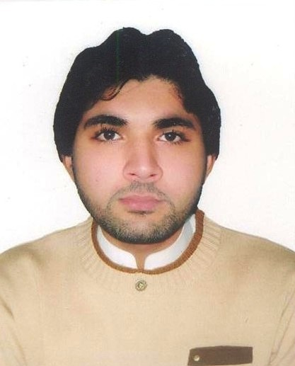

Career Objective:

To seek responsible and challenging job in your esteemed organization for a suitable post, where I will be able to apply my academic knowledge and work experience.

Professional Experience:

Team leader at FourSeasons Hotel and Resorts

Company Industry: Hospitality
Department: Housekeeping

April 2015 to till Date.

MAIN RESPONSIBILITIES

- Ensure all guest toilets are clean and smell fresh.
- Ensure all showers are clean and smell fresh.
- All toilets and Health Club facilities to be fully stocked with towels, toilet paper and toiletries. Ensure all guest changing rooms are clean and smell fresh, lockers clean and closed.
- Ensure that towel baskets are emptied regularly.
- Ensure all tiled floors (swimming pool, Health Club Reception and corridor, changing rooms) are cleaned with a Scrubber Dryer Floor Machine on a daily basis and carpet and stairs (by changing rooms) are hovered.
- Ensure all floor mats are clean.
- Ensure bins are empty.
- Ensure gym is hovered and window sills wiped, black mat mopped if needed.
- Ensure Studio is mopped and all mirrors are clean.
- Dust and wipe walls, doors, and table tops, walls to be kept mark free, all doors to be washed down as necessary.
- To follow and complete Health Club Public area cleaning daily check lists.
- Familiarize with all the functions happening in the hotel.
- To act upon guest requests and special requirements where necessary.
Housekeeping Supervisor at M Five Cleaning Service
Location : Dubai , United Arab Emirates
Company Industry: Hospitality
Department: Housekeeping
April 2011 to March 2015
Reporting to the Executive Housekeeper, and working closely with the Night Janitor Supervisor, responsibilities and essential job functions include but are not limited to the following:

- Consistently offer professional, friendly and engaging service
- Supervise a team of up to ten Public Area and room Attendants
- Oversee the daily cleaning of all hotel public areas, and rooms including performing sections audits, and monitoring daily checklists
- Assist in ongoing performance management of Public Area Attendants
- Work with the Night Janitor Supervisor to ensure that weekly, monthly and yearly projects are tracked and completed on schedule
- Assist in the daily cleaning of public areas as needed
- Follow departmental policies, procedures and service standards
- Report necessary maintenance items
- Follow all safety and sanitation policies
- Other duties as assigned.

Al-Mas Tower
Location : Jumeirah Lakes Towers Dubai , United Arab Emirates
Company Industry: Hospitality
Department: Housekeeping
April 2008 to March 2011

Personal Skills:

- Good Command of computer (MS-office)
- Ability to communicate effectively
- Ability to work extra hours
- Possessing leadership abilities
- Worked for various promotional jobs.

Qualification:

- SSC Board of Intermediate and Secondary Education in Multan, Pakistan.

Personal Strength:

- Hard working
- Dynamic, energetic, self-motivated and dedicated
- Quick learner
- Ability to act as willing Team player and to work in tens environment
- Dedicated and self- Motivated approach to the job

Personal Profile:

Name: Noman Rasheed
Father's Name: Abdul Rasheed
Date of Birth: 11 Nov1989
Place of Birth: Multan, Pakistan
Marital Status: Single
Religion: Muslim
Nationality: Pakistani
Sex: Male

Language Known as Read, Write, Speak and Type:

- Urdu, Hindi, English, fluently can speak, read, write and type.
- Arabic fluently can speak, read and write.

Mr. Noman
To interview Noman, send your company name, vacancy details with CV Reference No 1993086 to cvcontacts@gulfjobseekers.com

