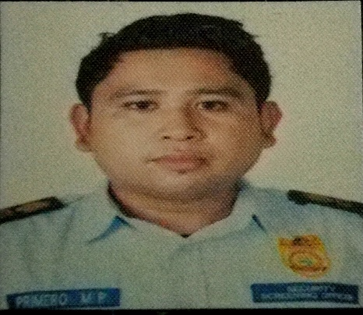

MARION
MARION.332198@2freemail.com

OBJECTIVE:

Seeking for challenging position where i can impart my experience and expertise i gained from my previous employment that would enable me to help and be a part of any organization. Looking an opportunity where i can improved my skills.

PERSONAL DATA:
Position desired :. Any position related to my profession
Date of Birth : June 18, 1989
Place of Birth : Mina, Iloilo
Age : 27
Gender : Male
Civil Status : Single
Citizenship : Filipino
Height : 5’ 6”
Weight : 85 kilos
Language Spoken : English, Tagalog, Hiligaynon
Address :. Alraha garden khalifa city
Home address (country) :. Mina iloilo Philippines
On tourist visa

EDUCATIONAL DATA:

College : John B. Lacson Foundation Maritime University

Course : Bachelor of Science in Customs Administration

Year Graduated : 2009-2010

Secondary : Mina National High School
Year Graduated : 2004-2005

Elementary : Mina Central School
Year Graduated : 2000-2001

Work Experience:

- Security Screening Officer
Aug.2013 – Dec. 2016
Office for transportation security
Iloilo international airport
- To ensure the security of air traveller, airline staff and others who work in and travel through our country’s airport
- To multitask and prioritized responsibilities
- To secure the airport users

- Barangay kagawad
Dec.2010 – Dec.2013
Department of interior and local govt.
Mina, iloilo
- Plan a good project to improve the barangay
- To make the people secured
- To be a good example to all the people in the barangay

- Store keeper
Jan.2010 – Aug.2013
Growers
Agricultural products
Mina iloilo
- Checking inventory and keep records
- Handling purchase and return
- Maintain the image of the store with good quality products
- Negotiate contract with vendors
- Slashed payroll/benefits administration cost 30% by negotiating pricing and , while ensuring the continuation and enhancement of services
- Bartender
- Help other server with food orders, running food or serving drinks
- Keeping my station clean, preparing the floor for the night shift
- Help in shutting down, restocking cleaning and preparing for the morning shift
TRAINING/SKILLS:

- Avsec screener refresher training
Feb 29,2016 – March 4, 2016
Transport security accreditation and training management service
Iloilo international airport
- Basic aviation security screener course
Aug 19, 2013 – Oct 5,2013
Institute for transportation security training and studies
Iloilo international airport
- Joe and the pirates bar and restaurant
Bartender
200 hours internship
Manduriao, Iloilo city
- Skills
Operate x-ray machine
Baggage inspector
Frisker
Mixed alcoholic and non alcoholic drinks
Inventory
Ms word
Security
Training

