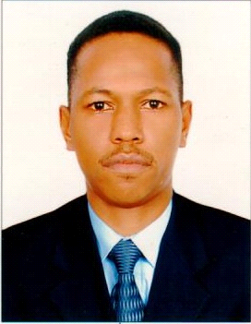
CURRICULUMVITAE
EMADALDEEN [
EMAD
DUBAI UAE
Email: EMAD.332210@2freemail.com
Personal Details
- Date of Birth: 02/08/1982
- Nationality: Sudanese
- Gender: Male
- Marital Status: Single
- Religion: Islam
- Languages Known: Arabic ,English
[
Educational Qualification
- EL Neelain University – Diploma-Information Systems Management.
- High School Certificate
- Computer Application Certification
- Police Competence Certificate

Working Experience
- Road &Transport Authority (RTA).
- City Services consultancy.
- National Communication Corporation_ MTN Telecommunications
- Omdurman National Bank
- Ministry of Interior Sudan H.Q Logistics Authority.
Position of Work
IT Help Desk – IT Coordinator
- Provide technical assistance and support for incoming queries and issues related to computer systems, software, and hardware.
- Write training manuals.
- Train computer users.
- Maintain daily performance of computer systems.
- Respond to email messages for customers seeking help.
- Run diagnostic programs to resolve problems
Call Center Representative
- Determines requirements by working with customers.
- Answers inquiries by clarifying desired information; researching, locating, and providing information.
- Resolves problems by clarifying issues; researching and exploring answers and alternative solutions; implementing solutions; escalating unresolved problems.
- Fulfills requests by clarifying desired information; completing transactions; forwarding requests.
Collection Agent
- Collect payments on past due bills.
- Create a list of people who have not made payments.
- Organize list according to severity of delinquency.
- Call customers using telephone.
- Inform clients of overdue accounts and amount currently owed.
- Ensure all customer information is correct, including phone numbers and addresses.
- Listen to customer's story and determine if debt can be collected.
- Offer advice or refer customers to debt counselors.
- Follow federal and state laws dealing with debt collection.
- Print reports for management.
Extra Experience
- Net workers courses.
- Customer service courses
- CCNA certificates
- Safety courses
- First Aide Corse three levels from Emirates foundation for Youth Development SANID Program as a Volunteer FIRST AID AED DEVICE
- Police Competence Certificate.
- Emirates driving licenses.
Declaration
I hereby declare that the above furnished information are true and correct to the best of my knowledge belief.

