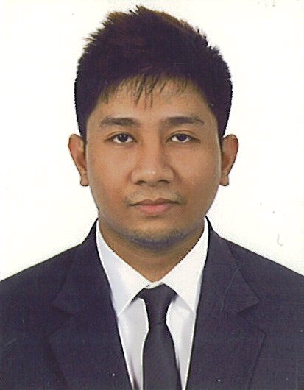
JOVEN CLARK PALABRICA – CV No. 1993272
Al Rigga Road, Deira
Dubai, U.A.E.

CAREER OBJECTIVES
To succeed in an environment of growth and excellence and earn a job which provides me job Satisfaction and Self Development and help me achieve personal as well as organization goals
QUALIFICATIONS:
- Equipped with excellent communication skills and can interact to persons of different personalities
- and management levels.
- Customer Service Oriented, Customer Focus, Phone skills
- Efficient, Hardworking, Honest, Self-motivated and ability to perform multiple task handle pressure
WORK EXPERIENCE:
Data Encoder/Office Clerk ( 2015-2016)
Duties and responsibilities:
- Ensure that confidentiality of data collected and stored are maintained
- Assures protection of the systems and data by performing at least one system back up per day.
- Assists when and where necessary in developing improved patient records management.
- Consults with software programmers and /or evaluators for troubleshooting database problems.
- Maintains accurate and up-to-date data.
- Attends required data entry trainings and meetings and provides input to enhance od data systems.
- Produces automated reports on request.
EDUCATIONAL ATTAINTMENT
Elementary Education S.I.R Elementary school
Secondary Education Davao City National High School
Vocational Course Computer Science

VISA STATUS: Visit Visa
JOVEN CLARK PALABRICA – CV No. 1993272

To interview this candidate, please send your company name, vacancy and salary offered details along with this or other CV Reference Numbers that you may have short listed from
http://www.gulfjobseeker.com/employer/cvdatabasepaid.php
addressing to HR Consultant on cvcontacts@gulfjobseekers.com

We will contact the candidates to ensure their availability for your vacancy and send you our service HR Consulting Fees quotation for your approval. Whatsapp +971504753686

______________________________________

