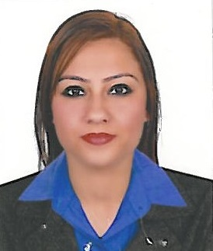 FAIZAH
FAIZAH.332215@2freemail.com

PERSONAL PROFILE:
A Professional team member with excellent administrative & interpersonal skills, along with good computer knowledge and substantial experience in the relative field. An enthusiastic and positive individual who enjoys taking up the responsibilities and teamwork.
OBJECTIVE:
To join an organization where I can grow and make better use of my professional acuities to a challenging position which requiring strong analytical and organizational skills with a better future and opportunities for professional growth.

PROFESSIONAL EXPERIENCE:

- NOOR AL HEKMAH TECHNOLOGIES L.L.C
(DU OFFICIAL CHANNEL PARTNER) – DUBAI, U.A.E. (Apr-2016 till date)
- Working as Sales Coordinator.

- Worked at DUBAI ISLAMIC BANK ( PAKISTAN)– (Apr-2015 till Mar-2016)

- Job Description at DUBAI ISLAMIC BANK:

- Providing Financial Solutions to customers.

- Responsible of direct sales of durable goods.

- Managing Auto Financing, Personal Loans and Home Loans.

- Assisting RM’s/BM’s in resolving customer’s query/investigation.

- Timely resolution of Customer Correspondence.

- Handles branch customers to fulfill their banking requirements.

- Monitor the service standards operational in branches.

- Providing information about the bank’s product and service offer.

- Regularly review customer’s complaints and resolve the complaints within particular time.

- Hiring Manager at LIS (Life Improvement System), Pakistan – (Jun-2011 till Jan-2013).

- Customer Representative at TIENS (TIANSHI INTERNATIONAL), Pakistan (Jan-2011 till Jan-2012)
CERTIFICATE OF MEMBERSHIP:
Completed “LEADERSHIP” training and upgraded to Hiring Manager post.
PROFESSIONAL EDUCATION:
- Bachelor of Business Administration (Hons.) – (Allama Iqbal Open University, Islamabad).
- Higher Secondary School Certificate – (Punjab College of Commerce, Islamabad).
KEY SKILLS:
- Highly motivated and determined to achieve career objective.
- Excellent IT Skills.
- Highly organized to meet deadlines.
- Flexible, quick learner with positive attitude.
- Proven ability to work without supervision.
- Professional integrity with strong work ethics.
- Excellent interpersonal communications skills.
- Highly organized towards team building.
- Managing group of skilled professionals to successfully achieve task within provided deadlines.
IT SKILLS:
Microsoft Office – Word, Excel, Power Point, Visio, Project, Web Based Management System.

