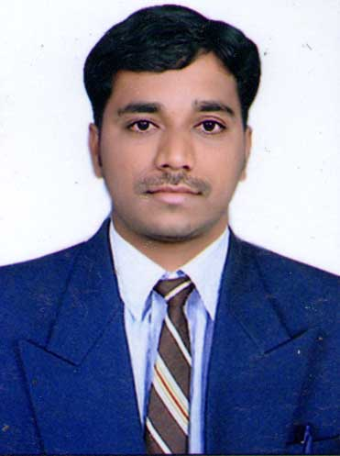

CURRICULUM VITAE

M. Rakesh

Rakesh.332222@2freemail.com

Post Applied For: Cashier

OBJECTIVE:

Seeking a challenging position in the field of Cashier C where I can apply my skills, in depth knowledge and experience with fully trained and highly graduated administrative staff with a vision towards contributing the continuous growth of the organization and my personal career.
EXPERIENCE : 4 Years

PRESENT EMPLOYER:

DUBAI :

Company : Ansar Mall, Hyper Market sharjah.
Designation ; Cashier
Duration : Jan 2014 to Feb. 2016.

PREVIOUS EMPLOYER:

INDIA :

Company : MANAPPURAM FINANCE LIMITED
Designation ; Accountant and Cashier
Duration : June 2010 to SEP 2011

INDIA :

Company : VARUN MOTORS NIZAMABD
Designation : CASHIER
Duration : SEP 2011 to MAR2012

EDUCATION & QUALIFICATION :

- Bachelor of Arts 2005-2008*60%
- Higher Secondary Commerce 2003-2005 *72%
- SSC *65%

SOFTWRE SKILLS :

- Certified Diploma in Advanceed Office Management (Ms- Word, Excel, Tally, Focus, Peachtree and Manual accounts)
- Typing Speed(35wpm)

RESPONSIBILITIES :

- The first duty of cashier is to greet entering in to organization
- Handling all the transaction of an organization

- Checking daily cash accounts.
- Guiding and solving queries of customer.
- Accurate posting of all income received by the University whether in cash, cheque or electronic payment received in any currency and use online banking for query resolutions.
- Count project area cash bags and prepare cash bags next day.
- Ensure cash vault is in balance daily.
- Handling difficult situations without any assistant.
- Previous experience in preparing cash deposits.
- Excellent in coordinating office administration and documentations requirements.
- Provinding training and assistance to new joined cashier.
- Maintaining Monthly, weekly and report of transactions.
- Solving all their cash realated quarries.
- Checking for the price off products any discounts or offers.
- Receiving coupons and deducting the said amount from the customers
- Organizing all the work they do and maintaining the accounting rcords
- Reporting discrepancies they find within the accounts to their superiors
- Making daily, weekly and monthly transaction reports
- Managing all the cash transaction in their workplace
- Maintaining daily account of the daily transactions
- Balancing the daily account at the end of each day
- Checking the daily cash balance
- Checking for the price of products and any discount or offers
- Receiving coupons and deducting the sad amount from the customers
- Manage product return and exchanges.

PERSONAL STRENGTHS:
- Proficicy using Microsoft Office applications (Word, Excel & PowerPoint), Outlook, internet and web based search tools.
- Excellent oral and written communication skills.
- Able to prioritize and possess effective time management.
- Ability to handle extremely detailed and highly confidential information
- Collect cash from customers or others if payment is by cash
- Diplomatic, will to win, and ability to close deals. Hard worker, honest, and reliable.
- Pay all invoices to be paid by cash.
- Do accounting operations relative to cash handling.

Personal Details:

Date of Birth : 18 June - 1988

Marital Status : Unmarried
Nationality : Indian
Languages Known : Telugu, English, Hindi
Hobbies/Interests : Listening Music & Travelling

Present CTC : AED 3500 /pm
Expected Salary : Negotiable
Date : 22/07/2016
Place : Hyderabad

