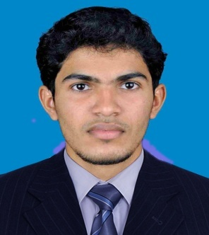

JITHESH
JITHESH.332232@2freemail.com

CAREER OBJECTIVE

To build a successful career in the field of Information Technology Industry, utilizing my analytical, problem solving, communication and interpersonal skills and fast learning abilities.

TECHNICAL SKILLS

- CCNA (Cisco certified network associate) –course done
- MCSA( Microsoft certified system associate) –course done
- MSExchange Server 2010: Exchange Server Managing and Outlook configurations.
–course done

- ITIL–course done

- Hardware: Assembly, troubleshooting, installation, configuration and maintenance of operating systems and software, partitioning, etc.

- Incident Resolving.

- Monitoring Application Servers.

- SQL Basic issues finding (Timeouts, Deadlocks, Blockings.etc).

- D-List Management Create, Modify, Delete –in Exchange Admin Center.

EDUCATION DETAILS
B.TECH.(IT) | KMCT College Of Engg., Kallanthode | 2013 | 64%
HSC | D.G.H.S.S, Tanur | 2009 | 74%
SSLC | G.H.S.S, Ezhur. | 2007 | 75%

EXPERIENCE
4view Technologies
Client Company: Gensuite Software Systems & Services Pvt. Ltd.
Designation: System Engineer
Department: IT
Experience: MAY 2015- JULY 2016

Roles and Responsibilities:

- Installs and maintains operating systems and third party applications.
- Maintaining the Antivirus Server and applying patches through Network.
- Day to Day backing up data.
- Maintaining and troubleshooting of desktop PC’s.
- Installing & Configuration of Troubleshooting S/W and H/W problems.
- Incident Resolving.
- Provide basic customer support.
- D-List Management Create, Modify, Delete –in Exchange Admin Center.
Skill and exposed area:

- Monitoring and maintenance of servers.
- Managing email, antispam, virus protection and their updates.
- Monitoring the Client systems for technical & software issue.
- Installs and maintains operating systems and third party applications
- Monitoring application errors, timeouts, database blockings and deadlocks.
- Maintaining and Configuring the 2003 and 2008 Server Active Directory, DNS,
- Maintaining and Configuring the 2003 and 2008 Server Active Directory, DNS,
- Basic Maintenance of 2003 and 2008 domain controllers.

AREA OF INTEREST
1. Network Engineer

2. Desktop Engineer

3.Network Support Engineer

HOBBIES
browsing ,traveling, listening to music , Playing cricket

B.TECH. ACADEMIC PROJECT
Main Project Title : 'Travel Enquiry Tracking System'

Mini Project Title : ‘ Insurance Policy Management System’

PERSONAL DETAILS
Name : Jithesh

Nationality : Indian

Date of Birth : 26 dec 1991

Gender : Male

Language : English, Malayalam, Hindi

DECLARATION

I hereby declare that all the above information are true and correct to best of my knowledge.

