CURRICULUM VITAE

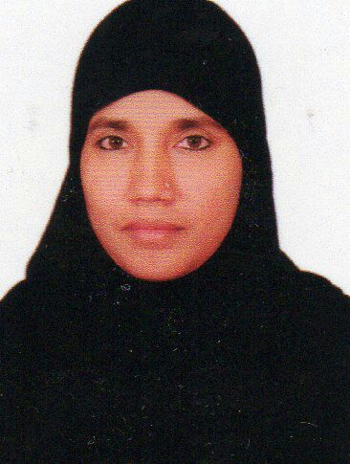

Yasmin

Email: yasmin.332235@2freemail.com

Objective

To apply my knowledge and experience in a competitive and growth driven industry, where I am able to add value and improve efficiency by contributing substantially and innovatively towards achieving company’s and individuals objective.

Academic qualification

B.A., in History, Madras University (1997)

Additional Qualification

Certificate course in Office Management (1994) from Annamalai University
Tamil Nadu, India.

Professional Experience

Worked in Front office in Aysha Hospitals Pvt Ltd., Chennai, India (2006-2016)

- Handling calls
- Data entry
- Registration for in-patients
- Registration for medical checkup for overseas employment.
- Having knowledge of medical terms and typing discharge Summary
- Billing for in-patient and OPD.
- Cash management.
- Record maintenance.
- Preparing Medical Insurance payment forms.

Hands on experience

- Knowledge of Microsoft office and Microsoft Excel.

Personal Details

Date of birth : 25-05-1973
Nationality : Indian
Marital Status : Married
Languages Known : English, Hindi and Tamil.
Visa status : Visit Visa

References on request

