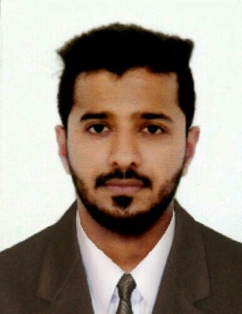
Safeer
Safeer.332250@2freemail.com

Public Relation Officer& HR Coordinator

Experienced Public Relation Officer& HR Coordinator seeking suitable position in your esteemed organization. Where I can utilized my ability develop through my education and experience

Summary:-

Highly-motivated, personable Public Relations Professional with HR Coordinator over 5 years experience in Construction firm. Efficient communicator with exceptional time management, problem-solving, and analytical skills. Flexible and adaptable to changing priorities

Education:-

HSE, (Kerala Higher Secondary Board) SSLC (Board of School)

Professional Experience:-

- Document Controller
Adarsh Developers Construction. Vittal Mallya Road, Bangalore, August 2015 - October 2016

- Ensures copies are distributed to all relevant personnel on time as indicated/ advised
- Maintained a soft copy of file index for easy reference
- Document distribution and retention
- Archived soft copies and backups
- Customer service – issue hard copy and electronic copy of document on user request
- Manage all Technical Documents (Drawing, Specification, Inspection Reports, Vendor Documents etc..,)
- Maintaining up t date Drawing/Document registers
- Issuing and distributing controlled copies of information

- Public Relation Officer & HR Coordinator
Horeitia Global W.L.L (Group), Doha- Qatar, July 2011 - January 2015
- Developed and organized meetings, workshops, ceremonies and other events
- Keep abreast with new labor laws & regulations.
- Responsible for planning, developing and implementing Public Relation strategies
- Arrange for new visas and entry permits for new hires.
- Process all immigration related applications to company staff and their families
including issuance
- Renewal of residence permits for all staff and their dependents and the company’s
business visitors
- Arrange for labor clearance for all expatriate employees
- Ensure and maintain proper records regarding employees’ official documents and
submit reminders to employees whenever documents require renewal
- Accompany new hires for finger printing and medical examinations processes

- Public Relation Officer
Royal Constructions, Mumbai - India, April 2009 - May 2011
- Ensure and maintain proper records of employees.
- Accompany new hires for finger printing and medical examinations processes. • Process all immigration related applications.
- Follow safe work practices and adhere to company guidelines and policies for
planning and executing work in a safe manner
- Keep abreast with new labor laws & regulations.
- Renewing Trade license, CR & Computer ID.
- Issuing & Renewal of Health Certificates through Health Department

Computer Skills:-
Windows, PowerPoint, Word, Excel, Adobe Photoshop, 3D Maya+

Language Skills:-
English, Hindi and Malayalam (Spoken, Writing and Reading)

Personal Information:-

Date of Birth : 02-03-1987
Sex : Male
Nationality : Indian
Marital Status : Married

STRENGTHS
- Hard working.
- Quick to grasp new ideas and concepts.• Adaptability.
- Co-operative and friendly.

DECLERATION:
I hereby declare that all the statements made in this curriculum vitae are true, and correct to the best of my knowledge and belief.

