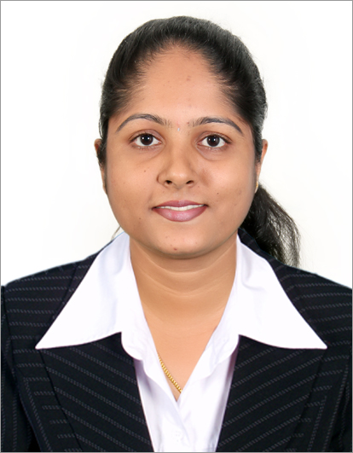

LAVEENA
LAVEENA.332265@2freemail.com

Objective:
To secure a challenging job where I can employ my education, experience and training to actively contribute to the growth of the organization, there by grow with the organization and be part of a winning team

Educational and Technical qualification:
Post graduated in commerce from Mangalore University, India in 2012 (specialization in Human Resource Development)
Graduated in Business Management from St Agnes College, Autonomous in 2010 (specialization in Marketing Management and Banking and Insurance)
Pre – University Education in Commerce during the year 2005-2007 from St Agnes P.U. College, Mangalore
Diploma in Computer Application and Tally

Work experience:
- St. Joseph College, Jeppu, Mangalore
From August 2013 to November 2016 (3.5 years)
Lecturer in Commerce and Management
Full time basis
- National tutorial, Mangalore
From June 2011 to 2013 (2 years)
- Edutech tutorial, Mangalore
From June 2010 to 2011 (1 year)

Job responsibilities:
- Developing and implementing new methods of teaching
- Designing , preparing and developing teaching materials
- Preparing power point presentations for the classes
- Delivering lectures, seminars and tutorials
- Assessing students coursework
- Setting and marking examinations
- Supporting students through a pastoral/advisory role and thereby looking into the overall growth of the students
- Undertaking continuous professional development and participating in staff training activities
- Assisting the principal in day today tasks in order to keep up the reputation of the institute
- Representing the institution at professional conferences and seminars and contributing to these as necessary
- Working towards the overall growth of the institute

Subjects handled:
- Commerce subjects:
Business Statistics and Mathematics, Business Economics, Costing and Management Accounting, Modern Marketing, Modern Banking, Auditing
- Management subjects:
Costing and Management Accounting, Investment Management, Human Resource Development

Core strength:
- Self-determined, confident, dynamic, highly energetic, hardworking, honest, good communication skill and fast learner
- Highly organized with ability to skillfully manage multiple tasks in fast paced multicultural environment
- Possessed with good computer knowledge like Microsoft word, Microsoft excel, power point, etc.
- Self-motivated and team player
- Ability to work under pressure under minimum supervision and meet with the deadlines with ease and efficiency

Seminars and workshops attended:
- A national level seminar on “prevention and elimination of violation against women: A social work perspective” conducted by Milagres college, Kallianpur, udupi
- UGC sponsored National level workshop on “Changing contours of indian Economy” conducted by St.Alloysious College, Mangalore
- UGC sponsored National Seminar on “Issues and Challenges in Global workplace” conducted by Besant women’s college, Mangalore

Personal information:
Date of birth : 04-07-1989
Gender : Female
Languages known : English, Hindi, Kannada, Konkani, Tulu
Nationality : Indian
Visa status : Visit visa (valid till 20-03-2017)

Declaration: I hereby declare that the information furnished above is true and accurate to the best of my knowledge. If given an opportunity I assure you that I will sincerely meet your expectations.

