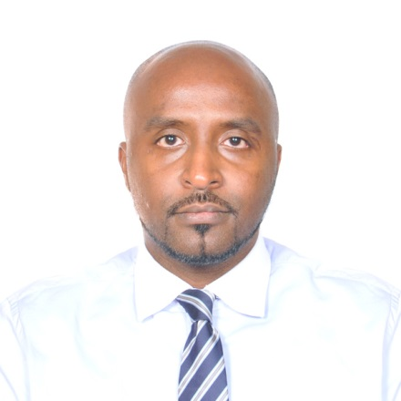
AMRO.332272@2freemail.com

AMRO

OBJECTIVE:
As a bright ambitious person, I enjoy working in a fast paced, highly motivating position where I can assist others while challenging and expanding my knowledge and understanding of the task at hand. I am seeking a position that will utilize my skills and offer the chance for advancement as well as allow me the opportunity to gain additional skills and experience.

PROFILE SUMMARY:
- Work in any environment and with any team.
- Work under pressures and realize other experiences and developing my experience.
- Good communicate with all type of people.
- System administrator Network Engineer and system Maintenance Engineer. Proficient in all areas related to the implementation, managing and maintaining Information Technology resources and services.
- Strong negotiation, interpersonal skills and attention to details.

WORK EXPERIENCE:
From 1/11/2009-until present, Al Ain Cromwell Hospital - City: Al Ain
Job Title: Senior System Operator
Responsibilities:
- Responsibility of managing and distributing IT related works on each other IT team.
- Responsible for the HIM, Windows OS, Antivirus. Windows 2008 R2 servers.
- User requirement study/survey and conducting user trainings.
- Master data maintenance and Domain administrator.
- Bug reporting and documentation-installing software patches.
- Configuration on network for the POS setup.
- Keep track on new user requirement and following up the process.
- Installation of network configuration for the PC, printer/scanner and other network devices.
- Maintaining the logs for technical support & service for the hardware/software from the supplier and troubleshooting.
- Configuring IP-Cisco telephone system extension and Cisco P.A.B.X router serves for the users.
- Maintaining lab interface result and analyze output.
- Design Employ ID card.
- Configuring time attends user and creating police for check in/out.
- Provide project status update to reporting manager on a regular basis and highlight for foreseen issues or project risks.
- Coordinate user acceptance testing to ensure delivered product is verified and accepted by the end users.
- Submit monthly KPI, IT services availability and compliance reports.
- Responsible for backup and restore data in case any disaster or required.
- Support and solve end issue related to HIM and local work stations.
- Responsible for Configuring and analyses for HIS ERP applications.
- Analyze and configure work flow for all new applications running within the organization.
- Maintaining and configure mail server users and backup.
- Domain administrator, configure users policy.
- Configure ERP.

From 21/3/2007- 25/5/2009, ADNOC-GASCO - City: Abu Dhabi-AL Ruwais
Job Title: Electronic and Telecommunication Engineering
Responsibilities:
- Calibration of electronic test equipment in instrument Dept.
- Communication P.A.B.X unit for upgrading the telephones lines.
- Communication installing new telephones lines and solving troubleshooting.
- Upgrading the new analyzers system in trains 1&2 process lines, also install new sample system point.
- Part of team for control room in auditing network cabling.
- Changing and Calibrate Analyzer System.
- Calibrate and Checking a Hazard area System for the analyzer.
- Maintenance of lab test equipment and calibrate cylinders for analyzer.
- Upgrading new system for cooling water control room.
- Install new Windows and M.S Office.

From 21/7/2006- 20/3/2007, Golden Hand Shop - City: Al Ain
Job Title: Electronic and Computer Eng.
- Work in maintenance and installing computer software/hardware.
PROFESSIONAL EDUCATION:

- BSc. COMPUTER ENGINEERING with Honor Degree – 2009
COMPUTER MAN COLLEGE FOR COMPUTER STUDIES (AL MASHERQ UNIVERSITY)

- Schools: Primary (Audltobah)-preparatory (Muwiaa)-secondary (Khalid).

COURSES:
- CCNA
- DBA Administrations in Oracle 10 certified
- Certified in Maintenance of Telephones
- Analyzer System

OTHER SKILLS

- Work in Sudan insurance and non-insurance in maintenance and telecom department for three month after graduate (1/1/2006-31/3/2066)
- Work for two weeks in GC 200 analyzer for Gasco.
- Work in two weeks in layout cables and joint for Gasco.

PERSONAL INFORMATION:

Date of Birth : 21/3/1981
Nationality : Sudan
Language Known : English, Arabic

-UAE Driving License

