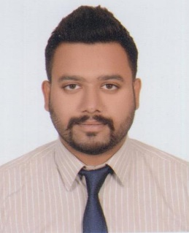
Arsalan

E-mail: arsalan.332306@2freemail.com

OBJECTIVE:

My Immediate career goal is to work with reputable organization having congenial working environment and where challenging opportunities are available to contribute towards the development of organization. Also I strive to ensure that a high degree of relationship is maintained between staff and colleagues.

CAREER HIGHLIGHTS:

- Sharaf DG (August 2015 – August 2017)
UAE
Sharaf Group comprises of over 60 operating companies in more than 6 business sectors. Sharaf DG deals in electronics & Operating 23 Stores in UAE.
Role: Sales Executive in Electronics Department at Alain Mall.
Responsibilities:
- Assist Customers & provide best solution as per his requirement.
- Achieving Daily /Monthly Targets which were assigned.
- Planogram Implementation & Display assortment along with correct prices.
- Department merchandising , PI count, Reconciliation, Stock report (Stock in Stock out)
- Achieved Margin drivers targets i.e. Extended Warranty, Accessories & other services which will increase profitability of store.
Achievements:
- Highest Achiever of Value & Extended Warranty.
- Continuously Achieved Performance Link Allowance (PLA).
- Best Salesman Award for Summer Gitex-2017.

EDUCATION:

- DAE : Mechanical and Instrumental Technology From Pakswiss
Training Center LAHORE (PCSIR)-2010
- SSC : Board of Secondary Education Karachi (First Division)-2006

OTHER SKILLS:

- Can work on MS OFFICE.
- Sufficient knowledge of AUTOCAD 2007 2D Drawings.

EXTRA CURRICULAR ACTIVITIES:

- Cricket, Football, snooker, web browsing, Games

LANGUAGES:

- English, Urdu, Punjabi, Hindi

PERSONAL DETAILS:

- DOB: 4-Dec-1989

