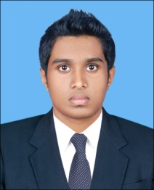

**Sharfas.**

[**Sharfas.332331@2freemail.com**](mailto:Sharfas.332331@2freemail.com)

**Objective**

To secure a challenging position in organization providing the opportunity to contribute, by utilizing and expanding upon experience and capabilities.

**Diploma in travel & tourism consultant**

Akbar academy, chavakad, kerala 2013-2014

**Higher secondary education 2011-14**

Central board of secondary education, Kerala ,India

**Secondary education 2010**

State Board Secondary Education, Kerala, India

**Bachelor of commerce**

Periyar University (Pursuing)

**Diploma in Graphic Designing Animation**

Jawaharlal Nehru education, Kerala, India

**M.S Dos,Windows Excel,Word**

Jawaharlal Nehru education, Kerala, India

**Diploma in tally& peachtree**

Cellcom education campus (govt. of Kerala)

**Akbar travels Kerala- India**

Travel consultant & ticketing

Communicates information to customers

Regarding fares, rates, schedules, routings, travel documents

(visa /passports) flight arrival and departure

Times or related services,

In a pleasant, and courteous manner

Worked as trainee in calicut international airport

**Areas of Expertise**

* Travel ticketing (Galileo)
* Fare calculation
* Customer relationship
* Abacus
* Aviation
* Ground service
* Hospitality service
* Travel management

**Career Experience**

**Personal Details**

: Marital Status : Single

Gende : Male Passport Number

Date of Birth : 18th october 1994 Nearest Airport : Nedumbassery

Nationality : Indian

Languages Known: English, Malayalam, and Tamil

**Academic**

**Achievement**