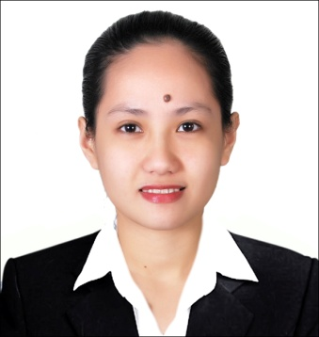
Stiffany
Stiffany.332333@2freemail.com

Objective: To use my skills and knowledge, also to enhance it into more useful things that I could be used in my work.

PERSONAL BACKGROUND:

Height : 5”2 Weight: 50 kg
Birth Date : September 18, 1992 Civil Status: Single
Age : 24 years old Religion: Roman Catholic
Birth Place : Paso De Blas

WORKING EXPERIENCE

- Medical Merchandiser
Product Image & Marketing Service Inc.
Unit 5 & 6 G/F J & L Bldg., 251 EDSA Greenhills, Mandaluyong City, Philippines
September 16, 2014 – December 31, 2014

- Coordinator
EPD CATERING LLC
United Arab Emirates, Dubai
DIP 2, Jebal Ali
April 2015 – December 31, 2016

Nature of Work:

- Receiving orders through e-mails.
- Sending welcome & re-welcome emails together with the invoice to the clients.
- Taking action & keep tracking records for all the clients’ complaints and concerns.
- Preparing everyday production plans for the kitchen.
- Make every day plans & managing the drivers.
- Making every day delivery lists.
- Maintaining the file for the operation such as:
- Waste management files.
- Calibration certificates of the company equipment’s and vehicles.
- Pest control files.
- Maintenance files of the company.
- Maintaining the overtime for the drivers.

EDUCATIONAL BACKGROUND:

Tertiary Bachelor of Science in Criminology
Our Lady of Fatima University
April 2013

Secondary Level Saint Catherine College of Valenzuela
202 Rosario Street Mapulang Lupa Vaenzuela City
March 2009

Primary Level Saint Catherine College of Valenzuela
202 Rosario Street MapulangLupaValenzuela City
March 2005

SEMINAR/TRAININGS ATTENDED

Disaster Response and Management Training Marulas, Valenzuela City
With Basic High Angle Rescue May 02, 2012

Awareness Drive on Crime and Our Lady of Fatima University
Drug Abuse Prevention September 02, 2010

Annual Pre – Employment Seminar Our Lady of Fatima University
February 02, 2013

Basic Food Hygiene Gems Training Centre (Dubai)
February 25, 2016

CO-CURRICULAR ACTIVITIES/ACHIVEMENTS

CAT – Company Commander, Delta Company
Saint Catherine School
2008-2009

Secretary, Women’s Criminology Organization (WCO)
Our Lady of Fatima University
2011 – 2012

Registered Criminologist
October 2013

SPECIALL SKILLS AND TALENT

I am good in sports and in multi – tasking. I am also Knowledgeable about some laws in the Revised Penal Code and Computer literate such as Ms Powerpoint, Ms Word and Ms Excell and MS Outlook.

I hereby certified that the above information mention is true and correct.

