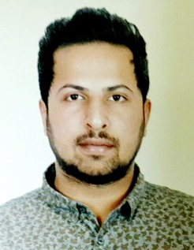

CURRICULUM VITAE

ABRARAMIR
ABRARAMIR.332349@2freemail.com

Personal Details

Current city Bur – Dubai

Date of Birth 04th November 1990

Nationality Indian

Visa Status Visit Visa

SUMMARY

A confident, energetic retail assistant who is passionate about high street fashion and excited by this challenging fast paced environment. Able to take initiative and plan efficiently without having to take direction at all times, and working in a fashion retail store that has a annual turnover of £2 million. A strong team leader with an entrepreneurial spirit, who thinks outside of the box, and enjoys being an ambassador for the business. Now looking for a opportunity to work for a company who truly value their staff and will strive to develop their career to the next stage

SKILLS

FASHION RETAIL PERSONAL

Styling Customer service skills Sociable personality
Art & Design Up selling Team player
Buyer IT literate Self motivated
Brand knowledge Marketing & Promotions Creative
Creative thinking Visual Merchandising Responsible
Fashion drawing Great sense of style Dedicated
Pattern making Stockroom Procedures High levels of Integration
Corsetry Attention to detail Loyalty

WORK EXPERIENCE
S Olivers - Fashion Consultant (June 2010 – October 2016)

Working as part of an enthusiastic team within a commercial, sales driven and fast paced fashion
Retail environment. Responsible for driving sales, ensuring good customer service, building
Relationships with suppliers, and ensuring the smooth running of the shop floor.

- Actively greeting customers and maintaining a level of conversation during their store visit.
- Taking decisive action to improve the branch performance.
- Dealing with all customer complaints in a professional and courteous manner.
- Sourcing major and unique fashion shows and events.
- Attending and representing the business at trade shows and external events.
- Promoting specific lines under the guidance of management.
- Unpacking and checking all new stock deliveries.

ACADEMIC QUALIFICATION

Degree | University / Board | Year
HSC | Mumbai | 2008

I hereby declare that the above given details are true and correct to the best of my knowledge and belief.

