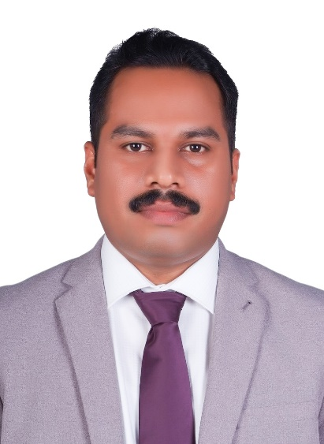  Personal Details  Date of Birth : 13th May 1979  Sex : Male  Nationality : Indian  Marital Status : Married  Visa Status : Employment(transferable)  Email : shummy.332368@2freemail.com  Holding a valid UAE Driving License  Areas of Expertise  - Logistic operations  - Regulatory compliance  - Budget setting & forecasting  - Logistics outsourcing  - Safety procedures  - Organizing shipments  - Transportation management  - Fleet management  - International Logistics  Personal Skills  - Excellent Communication Skills  - Time Management  - Socially Confident  - Constantly focused  - Problem Solver  - Optimistic  - Prioritizing  - Well organized  - Positive and amicable  - Self-Motivated  Languages Known  English  Hindi  Malayalam  Tamil  Educational Qualification  - Course completed Master of Business administration [MBA] from Mahatma Gandhi University, kottayam, kerala, India.  - Bachelor’s Degree in Economics [BA economics] from Calicut University, Tenchippalam Kerala, India.  - Pre-degree from Calicut University, Tenchippalam, kerala, India.  - S.S.L.C from the Government of Kerala Board of Public Examinations, Kerala, India.  Computer Knowledge  Aptech Certified E-commerce Professional(ACEP)  - Developing solutions with Visual Basic 6.0, Java 2, concepts of E-commerce & E-Business.  - Web Site Design and publishing with MS Front page, Manipulating data with SQL Server.  - Developing web applications with Visual Interdev 6.0 and ASP, Site Server Commerce Edition.  Post Graduate Diploma in Computer Education(PGDCA)  - Applications - Ms Office Tools.  - Good knowledge in MS-Excel.  - Good Knowledge in internet packages.  Activities & Interests  - Reading,  - Playing Badminton, Football,  - Driving and Traveling.  - Social Networking  - Movies  References  - Available upon request. | Shummy  Logistics/Shipping/Supply Chain/Oil & Gas
Career Objective
To obtain a challenging leadership position in a well-organized establishment which would utilize all my qualities, management knowledge, logistics & supply chain experience and moreover offers me new opportunities to play a creative and objective role with an enthusiastic approach enhancing the success of the organization.

Profile
Above 11 years’ experience in UAE, with the ability to work on own initiative, as part of a team and motivating team to achieve the objectives. Good analytical, Managerial and problem solving skills to maintain quality standards.

Summary
- Course completed a Master degree in Business administration [MBA] from Mahatma Gandhi University, kottayam, kerala, India.
- Attained a Bachelor degree in Economics [BA economics] from Calicut University, Tenchippalam, Kerala, India.
- Comprehensive knowledge of logistics procedures and processes
- Knowledge of national and international import/export legislation.
- Efficient in Ms Office Packages.
- Good knowledge in Internet packages.

Work Experience
- May 2014 to till date working as Logistics Coordinator with a leading player in oil space, Gulf Petrochem FZC in Sharjah, UAE.

About Gulf Petrochem: -
Gulf Petrochem Group is a leading player in oil industries, their business includes oil trading, Bunkering, Manufacturing & Refining, Storage terminals, Shipping & Logistics and other businesses.

Job Description:

- Booking shipment with carrier representatives and freight forwarders based on best quotes for freight charges for export/import.
- According to best freight rate quotes contacting carrier representative or freight forwarder to make arrangements for transportation and ensure timely placement of containers or ISO tanks
- Plan and co-ordinate transportation of materials and manage the timely flow of customer orders
- Contact carrier representative to make arrangements and to issue shipping instructions and delivery of cargo
- Checking and ensure customs documentation is properly done while dispatch of cargo
- Doing continuous follow-ups and coordination with FF/shipping line and trader. After receiving BL confirmation from trader collecting original BL from shipping line after vessel sailed.
- Booking and coordination for cross trade shipments (eg: cargo loading from Spain, Poland, India etc to other countries)
- Daily and monthly MIS report generation and submission to management.
- Making payment requests for freight invoices and getting approval from concerned dept HOD’s and submitting the invoices to accounts dept.
- As per SOA from Freight Forwarders/Shipping line doing payment follow ups with our accounts dept.
- Import shipment coordination (d/o collection, BOE & transport arrangement etc.)
- Monitor Shipment clearance status
- Maintaining imprest cash a/c for paying charges including BL, SBL, D/O, DP world, customs charges etc.

- June 2007 to May 2014 worked as Transport Executive with a leading transporting company, Al Razooqi General Land Transport.LLC in Dubai, U.A.E.

Job Profile:
- Oversees efforts to support and assist the organization in identifying and securing new Business opportunities.
- Following up new business opportunities and setting up meetings
- Market intelligence activities for the transport sector identify clients and needs
- Generate new business, including understanding customer requirements and creating customer quotes to fulfill customer requirements.
- Manages incoming inquiries from the transportation and logistics sector.
- Continuously monitor customer satisfaction
- Responsible for all transport operations of the company
- Arranging container transportation inside and outside of Jebel ali free zone and all over UAE.
- Responsible for delivering containers to the customer within the prescribed time.
- Give reports on the working condition of company vehicles and equipment.
- Coordinates the maintenance and repair of vehicles.
- Maintaining the daily/monthly trip sheets preparing and issuing quotations & invoices
- Coordinating the drivers and assign the tasks to drivers on daily basis
- Maintain courteous, prompt and efficient customer relations.
- Maintain an effective medium of communication and close collaboration among the workers in the organization.
- Communicate and liaise verbally and in writing between customers/suppliers/visitors/enquirers and relevant staff, and interpret and respond clearly and effectively to spoken requests over the phone or in person, and to verbal or written instructions.
- Establish and maintain effective working relationships with co-workers, supervisors and the general public.

- 15th October 2005 to June 2007 worked as Accounts assistant with a leading transporting company, Al Razooqi General Land Transport.LLC in Dubai, U.A.E.

Job Profile:
- Total responsibility of finance, control, accounts & administrative functions
- Manage petty cash and forward monthly reports to the management
- Responsible for receivable & payables of the firm
- Monthly segment-wise profitability analysis
- Prepare cash, bank, purchase and sales vouchers. Maintain cash & bank books, purchase, sales and ledgers. Take care of accounts payables and receivables.
- Prepare bank reconciliation statement.
- Timely reporting to the upper management
- Maintain the statements of accounts for every customers
- Collecting payments from the customers
- Maintaining monthly trip sheets of transportation
- Preparing and issuing quotations, invoices, vouchers etc.
- Managing payroll and ensure accurate, timely and efficient distribution of salaries
- Responsible for overall works in office administration
- Preparing reports and documents for proper recording and documentation of the functions and works of the company.

- October 1998 to September 2000 worked as Cashier at MCP Group, Irinjalakuda, Kerala.

Job Profile:
- Responsible in operating cash register
- Handling cash and credit transactions
- Accounting the daily revenue of the supermarket
- Manage petty cash and forward monthly reports to the management
Timely reporting to the upper management

DECLARATION

I hereby declare that the above shown details are true to my best knowledge and belief.

Place: Dubai
Date: Shummy

