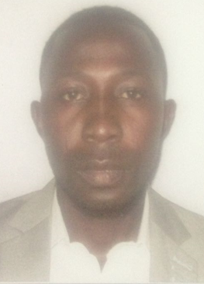

CURRICULUM VITAE

AFEEZ
AFEEZ.332386@2freemail.com

CAREER OBJECTIVE:
With interest in computer science, with a teachable spirit, positively contribute to provide speed growth and development in the organization via learning and utilizing of personal and learned skills, serve passionately and tirelessly for excellence. High creativity and a good team player to aid in achieving organization goals and objectives through team work.

PERSONAL DETAILS:

- Date of Birth: 25th March, 1988
- Gender: Male
- Nationality: Nigerian
- Visa Status: Tourist Visa
- Language: English language

ACADEMIC QUALIFICATION

- B Tech Computer Science 2nd Class lower Division
- Senior Secondary Certificate Education
- Primary Leaving School Certificate

WORK EXPERIENCE
UNILEVER NIGERIA PLC
POSITION: ADMINISTRATION DURATION: 2013 - 2015

JAVY ROYAL MODEL COLLEGE
POSITION: COMPUTER SCIENCE TEACHER DURATION: 2015 - 2015

PERSONAL SKILLS AND ABILITY

- Excellent Human Relation Skills
- Good Communication and Interpersonal Skills
- Ability to get good, desired results and attention to details
- Ability to work enthusiastically with or without supervision
- Ability to resist pressure, good team player and ability to adapt

REFERENCE:
- Will be furnished upon request

