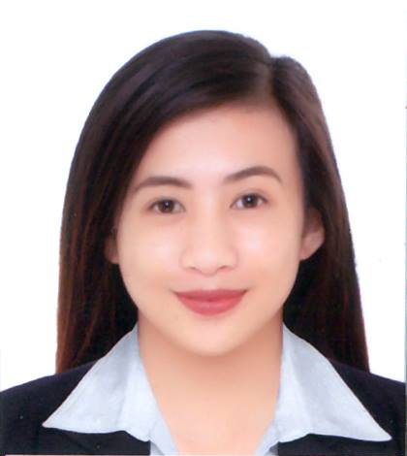
DIANNE

DIANNE.332399@2freemail.com

OBJECTIVE

To obtain a suitable position in a working environment that provides challenge, motivation and professional growth enabling me to apply my academic knowledge, expertise, job experiences, and utilize my skills while meeting the company’s goal and objectives.

SKILLS:
- Knowledge in Microsoft Office Applications (MS Word, MS Excel and Powerpoint)
- Internet Knowledge
- Excellent in Written and Oral Communications

CORE COMPETENCIES:
- Highly motivated and hardworking
- Reliable and responsible
- Adaptive to change and to diverse individuals
- Ability to withstand pressure
- Set priorities and meets own commitment timely

WORK EXPERIENCE:

Educational Facilitator
Stella Maris Academy
Bacnotan, La Union, Philippines

Baguio City National High School
Governor Pack Road, Baguio City, Philippines

Saint Louis University-Laboratory Elementary School
General Luna, Baguio City, Philippines
October 2015-April 2016

Job Description:
- Make preparation reports of activities composed of objectives, ice breakers, main activity, processing questions and conclusion, and communicate those objectives to students.
- Establish and enforce a classroom code of conduct to maintain a positive learning environment for students during all activities.
- Prepare necessary instructional materials that can contribute to the understanding of students in completing task in relevance to the objectives.
- Plan and conduct activities for a balanced program of instruction and demonstration that provide students to work as collaborative team as they accomplish their group goals.
- Observe and evaluate student’s performance, behaviors and social development.
- Provide positive environment in which students are encouraged to be actively engaged in the learning process.
- Share core values and principles, discuss what they mean so the students can learn to adapt and to act consistently with a more effective set of values and beliefs.
- Compile and report evaluation feedback.

EDUCATION ATTAINMENT

Tertiary Education Bachelor of Science in Psychology
Saint Louis University-Baguio City
- Bonifacio Street, Baguio City, Philippines
2012-2016

COMPETENCY SKILLS/ SEMINAR AND TRAINING ATTENDED

- Registered Psychometrician
Manila, Philippines
September 2016

- Seminar workshop on Team Building and Icebreakers
Saint Louis University-Baguio city
September 2015

- How to deal with difficult people
Saint Louis University-Baguio city
November 2015

PERSONAL INFORMATION

Date of Birth: January 19, 1996
Age: 20
Gender: Female
Civil status: Single
Citizenship: Filipino
Religious Affiliation: Roman Catholic
Visa Status: Visit Visa

CHARACTER REFERENCES

Available upon request

I certify that the above information is true and correct to the best of my knowledge.

