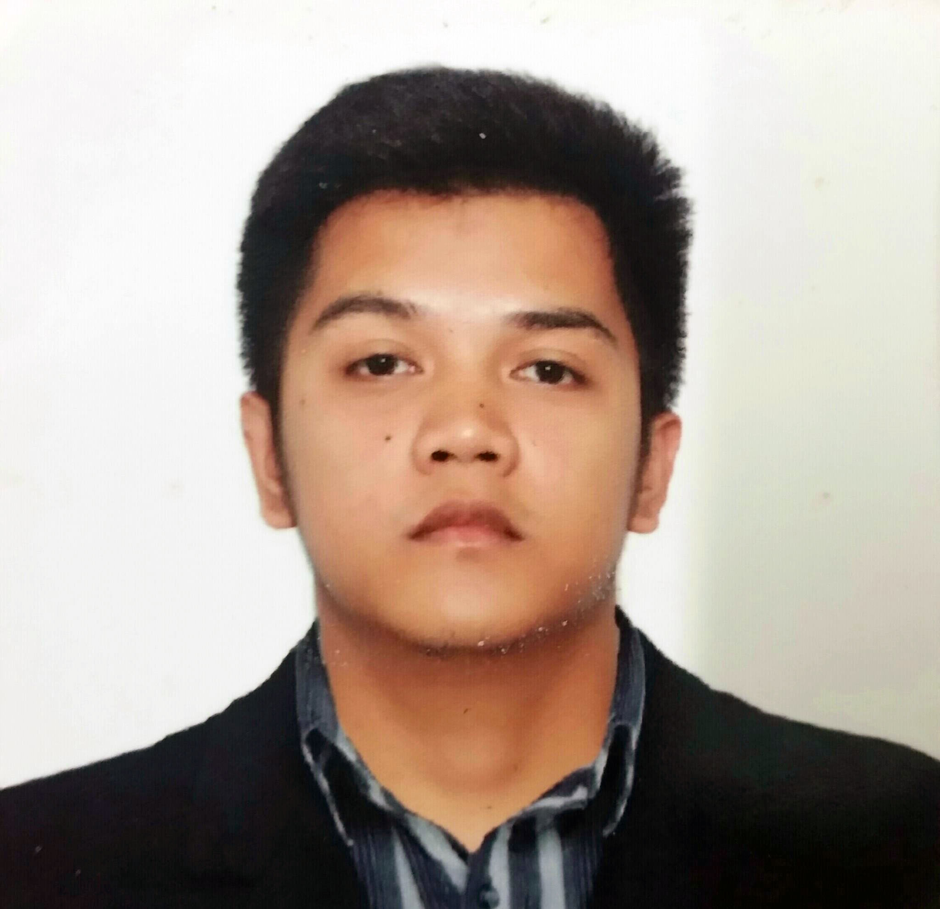Mark

Mark.332406@2freemail.com
Al Rigga, Deira, Dubai, UAE

JOB OBJECTIVES:
- To seek a position where I fully utilize my knowledge, skills and attitude.
- Technical capability through continuous training and education, to grow in my mind and in my heart

WORKING EXPERIENCE

Office Clerk/ Computer Teacher/MIS Coordinator
Cabanatuan City Christian Institute
June 2014 – March 2016
Tasks and accomplishments
- School Program documentation
- Filing of Documents
- Troubleshooting of computer Hardware and Software
- Picture documentation of all events in the school
- Supreme Student Government Adviser
- In-charge in the maintenance of Computer Laboratory Hardware and Software
- Creating Microsoft Database of Books for the Library
- Creating Certificates for the Events in the School

ON-THE-JOB TRAINING EXPERIENCE
On-The-Job Training 1 (250 Hours)
Department of Education, Division of Nueva Ecija
Accounting Section
DepEd Division of Nueva Ecija
Old Capitol Compound, Cabanatuan City (3100), N.E. Philippines

TASKS GIVEN DURING THE TRAINING:
Clerical Work, Photographer and Photo-editing
On-The-Job Training 2 (250 Hours)
Legal and Administrative Department
DepEd NCR Division of Pasig City
Caruncho Ave., San Nicolas, Pasig City Philippines
March 2013 – May 2013

TASKS GIVEN DURING THE TRAINING:
Clerical Work, Created a simple database for employee’s leave record

Achievements:
Licence Professional Teacher

EDUCATIONAL BACKGROUND:
TERTIARY:
Bachelor of Science in Information Technology
Nueva Ecija University of Science and Technology
Cabanatuan city, Nueva Ecija, Philippines
June 2010- April 2014
Post Graduate:
18 Units of Professional Education Subjects
Araullo University, College of Education
Cabanatuan City, Nueva Ecija, Philippines
SECONDARY:
Philippine Statesman College
Cabanatuan City, Nueva Ecija, Philippines
June 2006- April 2010

SEMINARS ATTENDED:
Cybercrime Law and Ethics for IT Professionals
Auditorium, NEUST Main Campus, Sumacab Este, Cabanatuan City
November 22, 2012

11th Philippine Youth Congress on Information Technology
SMX Convention Center, Pasay City
September 19, 2013

16th Annual Leadership Training Seminar: Leadership Challenges Towards PAVREA (Poverty Alleviation, Violence Reduction, and Environmental Aggradations)
NEUST, Sumacab Campus June 28-30, 2013.

This is IT: Mindset of Successful IT Professionals
Auditorium, NEUST Main Campus, Sumacab Este, Cabanatuan City
February 21, 2014

Virtualization of Data Centers
Subic Bay Exhibition and Convention Center, Subic Bay Freeport Zone
December 10, 2013

Skills and Abilities:
- Computer literate
- Efficient with Microsoft Office 2003 / 2007 / 2010 / 2013 Application
- Word, Excel and, PowerPoint, Access, Publisher
- Typing (average: 30 - 45 words per minute)
- Video editing with PowerDirector 9 and 10
- Basic Photo Editing in Photoshop CC
- Basic UML diagram
- Basic MY SQL Databases
Personal Data:

Age : 23 years old
Date of Birth : December 19, 1993
Place of Birth : Cabanatuan City, Nueva Ecija, Philippines
Sex : Male
Civil Status : Single
Citizenship : Filipino
Religion : Catholic
Weight : 75 Kg
Height : 5’6
Visa Status : Tourist Visa - Expiration 02/06/2017

I hereby certify that the above information given is true and correct.

