Chef Manzoor Hassan Balghari – CV No. 1994454

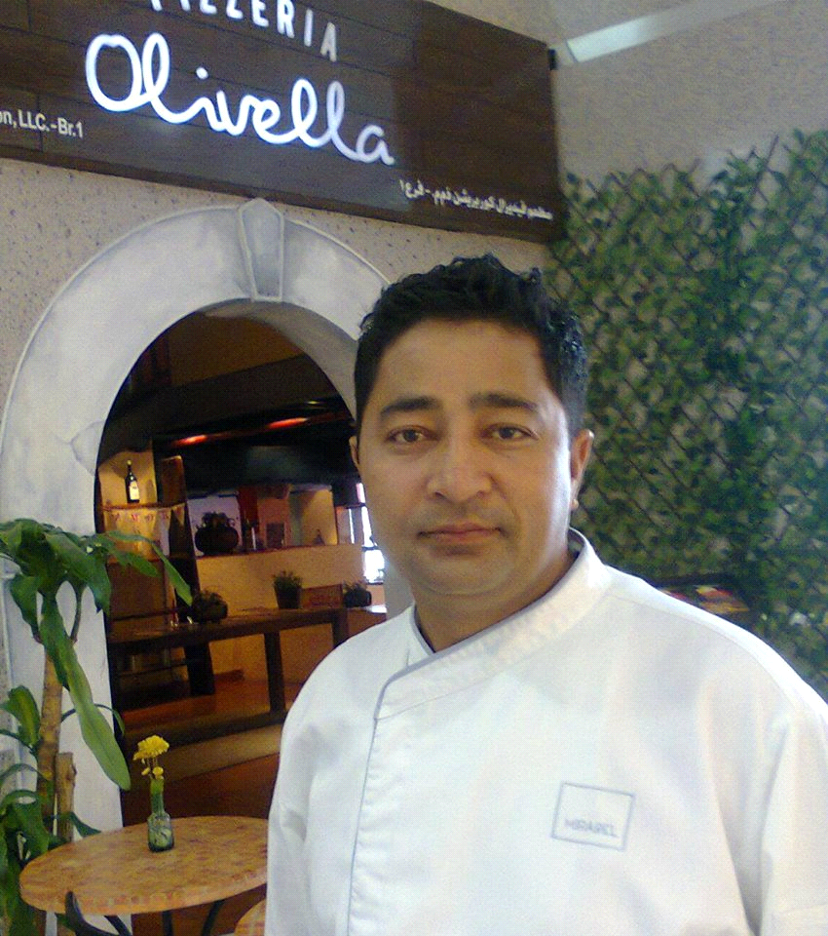

Objective:- | Excelling the career in professional environment where I can grow, deliver significant moral values to the society and may become member of tolerated crew as well.
SKILL SET:- | COMMUNICATION SKILLS:  Adapt at the use of right communication channels whereby communicating message to the subordinates and to the top management.  INNOVATIVE:  Developed new means and ways of keeping a track of performance and an action plan to improve the performance thereby creating a surely successful operation.  RESULT ORIENTED:  I believe performance is more described through actions than words.  INTERPERSONAL RELATIONSHIP:  To develop strong inter-personal relationships with the management to be cohesively bond with the company and integrate them with the vision and core values.  COOKING SKILLS:  Cooking knowledge of Italian, Thai, Chinese, Japanese, tepinayaki, Tandoori grills, Pakistani / Indian Cosine, Mexican, continental,Sandwiches,Pilipino food, expert in Out Door Catering, Banquet Specialist, live cooks for vip functions and outdoors caterings
Experiences: - | March 2015 to update  Head chef  Main Responsibilities:  - Supervise all phases of food production area.  - Cheek daily production charts against house count and expected business.  - Adjust estimate of the daily flow of business if necessary eliminating over production and waste  - Check food service during all meal period to ensure food meets our portion control and quality standards. Follow up and updates use records.  - To select and interview staff in conjunction with the Executive chef and the Human resources department.  - Ensure that all staff adheres to all fire, health and safety procedures.  - Follows up to see banquet event orders are properly coasted.  - Checks inventories to see proper storage and rotation of stock.  - Conduct taste panels.  - Ensure that all associates are on time for work.  - Maintain a safe working environment with a follow up by repair order to achieve departmental standards and goals.  - Maintain and supervise good housekeeping practices in all food production areas, strictly enforcing our Clean as you go policy throughout all reach ins,walk-ins,freezers,machinery and other equipment.  - Establish system and methods of operation to ensure cleanliness and hygiene in all back areas to standards set as cost effectively as possible.  - Communicate any problems with outlets to the affected department head and the executive chef for follow up.  - Assign schedules and supervise all production in all kitchen areas.  - Aid in cross training and development of all food production employees with in the area.  Establishes appropriate training for all kitchen staff to achieve departmental standards and goals and to assist in personal development.  April 2014 to march 2015  Head chef  Panifico DIFC United Arab Emirates  28 February 2013 to 30 December 2013  Sous chef  Hallmark hotel Deria  1st September 2011 to 28 February 2013  Sous chef  Al Habtoor Delight Catering (Al HabtoorValtrans)  1st March 2011 to 25th August 2011  Crown plaza Dubai Deira  Asian chef  22nd December 2004 to 28 February 2011.  Renaissance Hotel Dubai Demi chef de partie spice island restaurant
Pearl continental hotel Lahore
Chinese chef
15 th August 2002 to 20 th October 2004

5th September 2000 to 10 August 2002
Buddyz Café veranda (Bar B.Q)
Assistant Chef

Jan 15th 1998 to 20th August 2000
Holiday Inn hotel Lahore
Working as commis 1

Professional Achievements &Training | - Successfully completed the Telephone Courtesy and Standards 23 – 24 January 2004  - Successfully Completed the Firefighting Training on 24 Feb 2004  - Certificate of training for completing Orientation 23-24 January 2005.  - Successfully Completed the Savvy Serve program on 30 October 2005.  - Foundation Certificate in Food Hygiene Chartered Institute of Environmental Health 26 September 2005.  - Passport to success level II Certificate of accomplishment "Culinary Basic & General knowledge” 30, July 2006.  - Passport to success level III Certificate of accomplishment “Break Fast Cookery” 27 October 2006  - Emirates Culinary Guild a Merit award for "practical cookery-3 types of soup" at the Middle East junior chef of the year 2006.  - Senior member of Emirates Culinary Guild Dubai United Arab Emirates.  - Fellow member of Chef Association of Pakistan.  - Certificate of 100% leaders July 2007.  - Certificate of accomplishments of HACCAP awareness training 23 November 2008.  - Great Food Safe Food Training March 30, 2009.  - Basic Food Hygiene Training 15th December 2009.  - Complete five years’ service with Marriott.  - Training as Hygiene Officer in kitchen April-July 2010 Renaissance Dubai hotel.  - Emirates Culinary Guild a Merit award for Fishand seafood practical cookery at The Emirates Salon Culinary-Dubai 2011.  - Emirates Culinary Guild a Merit award for Poultry Practical Cookery at The Emirates Salon Culinary-Dubai 2011.  - Certificate of Guinness world record for participating in setting new World Record for the world largest Gathering of chef at Meydan race Course Dubai, UAE4 January 2013.  - Certificate of participation Seminar Health talk (Diabetes & Low GI) ON 17thJuly 2013 at Radisson Bluhotel.Deira Dubai organized by Chef Tech, ECG, and Zuleika Hospitals.  - Basic Food Hygiene Training 31 st August 2013.  - Certificate of participation USpoultryWorkshop at Radisson Bluhotel.Deira September 2013.  - Certificate of participation US poultry Workshop at Radisson Bluhotel.Deira October 2013.  - Certificate of participation us turkey at Radisson Bluhotel.Deira 5th October 2013  - Certificate of Training “Building a successful team “9 th October 2013.  - Certificate of participation U.S.Beef HRI Training workshop at Radisson Bluhotel.Deira December 21,2013  - Certificate of completion U.S.Lamb HRI training workshop at Radisson Blu Hotel Dubai Deria Creek on April 26, 2014.  - Certificate of participation U.S.Beef HRI training workshop at Radisson Blu Hotel Dubai Deria Creek Saturday, June 14, 2014.  - Certificate of successful completion Basic Food Hygiene Training on 10 August 2014 Al safa consultancy and hospitality services  - Certificate of participation US poultry Workshop at Radisson Bluhotel.DeiraNovember 2014.  - Participated in senior chefs workshop on Caviar and smoke Salmon production& serving by Sea horse fresh seafood on February 2016  - Completed a seminar in Cooks & chill Raw Fish Cooked Differently at ICCA Dubai on 23 January 2016 by Electrolux innovation center in Dubai U.A.E.  - Essential Food Safety training certificate Abu Dhabi Food Control Authority by Syscoms College Abu Dhabi. Valid until 22 March 2021.  - Certificate of participation U.S.Beef HRI Training workshop at Radisson Bluhotel.Deira May 2016.  - Certificate of appreciation for Marshal at East Coast Salon Culinaire Fujairah June 2016.
Personal Skill : | - Certificate in computer sciences from Menhaj Computer College Lahore Pakistan from 5th August 1999 to 5th February 2000.  - Valid UAE Driving License NO 927765 (Issue: 06/08/2005 Expiry: 06/08/2025)  - (ILETS) - International English Language Testing System 2009.
Appreciation Certificates: |  | - Excellent Performance in the month of December 2002 achieved highest monthly revenue in the history of Pearl Continental Hotel Lahore Pakistan, 29 January, 2003.  - Personal involvement Annual sales conference May 30 to June 1, 2003 Pearl Continental Hotel Lahore Pakistan.  - Renaissance Dubai Hotel December19, 2005.  - Renaissance Dubai Hotel 9 May, 2006 for (Marriot club 1000 Dinner)  - Renaissance Dubai Hotel 13, May2006.  - Great Achievement Award for achieving Dhs.1, 000,000. (Revenue in Spice Island)
Education : | - BA (Bachelor of Arts)  AllamaIqbal Open University  Islamabad Pakistan 2007  - Diploma Hotel Management&Tourism Sep 2000 to Aug 2002  TDCP-Institute of Tourism & Hotel Management Lahore Pakistan  - Higher secondary School Certificate  AllamaIqbal Open University Islamabad Pakistan 2003  - S.S.C (Secondary School Certificate)  Federal Board of Intermediate & Secondary Education Islamabad Pakistan  1998.
Personal Information: | - father’s name: Hassan Ali  - Nationality . Pakistani  - Passport no: AC3722723  - Passport expiry date: 7 February 2026  - Date of Birth: 24-06-1983  - Status : Married  - Religion : Islam
Hobbies: Cricket, music, driving,
Reference:Swill be furnished upon on request

Chef Manzoor Hassan Balghari – CV No. 1994454

To arrange interview with me, please send your company name, vacancy and salary details to my HR Consultant cvcontacts@gulfjobseekers.com Whatsapp +971504753686

______________________________________

