Krishna Kumar.K.R – CV No. 1994700

Application for the position of
CHEF DE PARTIE

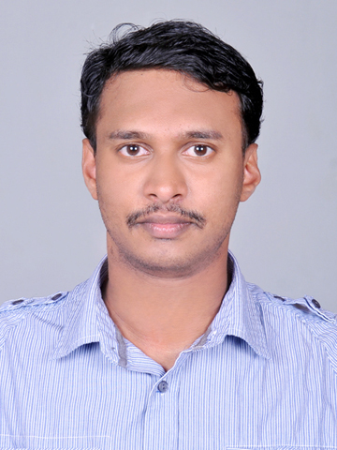

Objective:-
To secure a challenging position in the hospitality industry that provides an opportunity for growth by fostering my talents and experience to handle any challenging situation tactfully and efficiently thereby, improving my leadership qualities.
Job summary does as General:-
- Ensures that high standards of sanitation, cleanliness and safety are maintained throughout all kitchen areas at all times.
- Establishes controls to minimize food and supply waste and theft.
- Cooks the items that require skillful preparation.
- Periodically visits dining area when it is open to welcome members

Career History:-

Chef de Partie Crown Plaza ( IHG Kochi,Kerala India)
Worked in Coffee Shop and All day Room Dinning Kitchen
August 2014 – Present
• Preparing all Order by company standard and presenting the same in a delicious manner
• Handling the entire operations in absence of sous chef.
• Assist the Chef on daily duties in the kitchen
• Controlling the food quality & portion and minimizing the wastage
• Ensuring work environment to be very clean and safe
• Ensuring all Mis-en-place is up to date
• Handling ordering and inventory on daily basis
• Maintaining proper storage procedure as specified by health department and standards set by the hotel
• Checking and verifying food items and ensuring the quality in time
• Spearheading various other duties as assigned and needed

BurjAlArab Al bab al yam Restaurant

Commis I
2013 April to August 2014

* Work in , Continental a la carte' restaurant.
* Prepare mise en place.
* Maintaining Food & Beverage hygiene.
* Maintaining preparation standards.
* Ensure cleanliness of refrigerators in section for which responsible and working area tidy and clean.
* Took a responsibility for HACCP.
* To keep proper kitchen storage procedures first in and first out (FIFO).
* Communicating effectively and keeping other informed.
* To keep all kitchen utilities & equipment's are maintained in good condition.
* Ensure the minimum use of energy at all times.
* To be discreet and keep observations confidential and report to Chef de Partie.

Hotel Bonington Jumeirah Lakes Tower
Commi -I
Mcgettigans Irish Pub Kitchen
Dubai, U.A.E
September 2011 to February 2013

• Responsible for the preparation of food items ensuring that the hotel standard is met.
• Prepares for the mise-en-place for the next day.
• Responsible for inventory, preparation and presentation of select dishes and food items.
• Directs subordinates or other helpers in dishing foods, preparing portions, serving and cleaning work areas and personally participates in such tasks.
• Perform other related work as required.
• Assists with another station when needed.

Abu Dhabi Golf Club
Sas Al Nakhl, Abu Dhabi,
Commis 1
January 2010 until August 2011

• Do Live cooking for breakfast (egg station) and lunch (pasta, carving..)
• Responsible for the preparation of food items ensuring that the hotel standard is met.
• Prepares for the breakfast mise-en-place for the next day
• Perform other related work as required.
• Assists with another station when needed.

Lotus Hospitality (NMC Group)
Lotus Boutique Hotel, Dubai Deira
Commis II
June 2007 until July 2009

Strengths
- Ability to prioritize and adaptable to changes.
- Good leadership qualities and very confident.
- Efficient work attitude.
- Strong interpersonal skills.
- Departmental trainer-to improve the skills of the associates.
- Leadership skills and communication skills.
- Able to set a good example to colleagues.
- Flexible and willing to learn and adapt to new ideas and concepts.

Educational Attainment

- Passed Diploma in Professional Cookery from IIMS Cochin on 2006
- Award in HACCP Awareness Program ,Completed training and a assessment .Conducted by APEX FOOD CONSULTANTS -DUBAI UAE.

Training Experience
6 Month Industrial Exposure Training in Malabar Palace 2007 ,Kerala, India.

Declaration:-
I do here by certify that the above particulars given by me are true and correct to the best of my knowledge.

Krishnan Kumar K.R.

Krishna Kumar.K.R – CV No. 1994700

To arrange interview with me, please send your company name, vacancy and salary details to my HR Consultant cvcontacts@gulfjobseekers.com Whatsapp +971504753686

______________________________________

