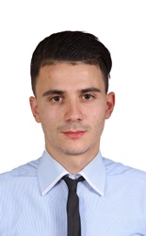

**Personal and work skills :**

**Language spoken and written :**

English (Fluent), ARABIC (Fluent),  French (fluent )

Young , responsible, dynamic and passionate about working with people and team spirit .

**EDUCATION :**

**2014 – 2015** **| Bachelor degree of letter and philosophy**

Independant candidate in baccalaureat – Relizane , Algeria .

**2015 – 2016** **| Licence in english literature ( First year LMD level )**

Ahmed zabanna university Centre - Relizane , Algeria .

**2016 – 2017 | Licence in socielogy and human science ( First year LMD )**  Ahmed zabanna university centre – relizane, algeria

**Professionnel experience :**

**2012 – 2013** | **Sales assistant in ZARA store algiers ( Full time ) .**

* work on variety of sales areas.
* selling, presenting, customer service, storing and ordering merchandise in a retail operation..

.

**2013 –2014 primark clothing store (full time ) .**

• Assist in display of Storage of goods and Advise customers on utilization and care of merchandise .

**Mohamed**

[**Mohamed.332478@2freemail.com**](mailto:Mohamed.332478@2freemail.com)