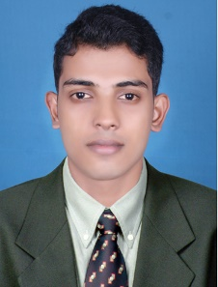  ABOUT ME  I am a Microsoft certified Professional with B-tech Computer science graduation. I have been working as an IT Support Engineer in Irfan Network Solutions and HCL Technologies  SKILLS  WORK  DESKTOP  SERVER  PERIPHERALS  NETWORKING  HARDWARE  PERSONAL  COMMUNICATION  ORGANIZATION  TEAM PLAYER  CREATIVITY  SOCIAL  LANGUAGES  English : Read, Write, Speak  Hindi : Read & Speak  Malayalam: Read, Write, Speak  Tamil : Speak  Arabic : Read | MUHAMMED  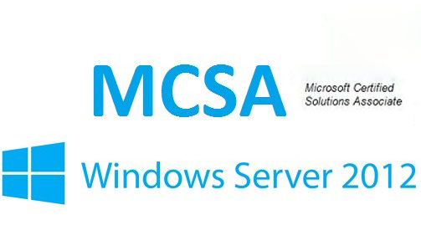  Muhammed.332514@2freemail.com  IT Support Engineer  EDUCATION  2010 – 2014  BACHELOR OF TECHNOLOGY (First Class)  COMPUTER SCIENCE AND ENGINEERING  University of Calicut, Kerala, India  2007 - 2009  HIGHER SCHOOL CERTIFICATE (73%)  PTM Higher Secondary School, Thazhekode, Kerala  TRAINING COMPLETED  - Computer Hardware (PC & LAPTOP)  - CCTV Installing and Management  - Microsoft Exchange server 2013  - Cisco Certified Network Associate (CCNA)  - VM ware Certified Professional (VCP) in Data Centre Virtualization  CERTIFICATIONS  - Microsoft Certified Solution Associate  in Windows Server 2012r2  Microsoft certification id:  EXPERIENCE  HCL Technologies  Air India, Bangalore International Airport  DESKTOP SUPPORT ENGINEER April 2016-September 2016  - Monitoring and reporting LAN and WAN [Head Office, Cargo, and Airport]  - Installing and configuring Windows Desktop XP, 7 and Driver software  - Monitoring Intranet and Internet of Air India using freeping and reporting  - Install and Configure Microsoft Office 2007  - Local and Network Printer/Scanner Installing troubleshooting  - The Internet Proxy & WIFI Troubleshooting(2 Proxies: HAL and Delhi)  - Software troubleshooting update and patch installation  - Remote assistance using VNC and Ammi admin & telephonic support  - Antivirus Kaspersky installation and monitoring  - PC Backup & Hardware repair/ replacement
INTERESTS  Computing  Traveling  Swimming  Football  Socializing with friends  Movies  SKILL SUMMARY  Technical Support:  Windows XP,7,8,10  Server OS: Windows 2012r2  MS Active Directory  MS Outlook  MS Office  Exchange Server Administration  File Server  Printer and Scanner  User Profile backup  Antivirus and Patches  Disk management and partition  Network Support:  LAN & TCP/IP  Firewall Administration  Map Drive/ Sharing  DHCP, DNS, IIS, VPN  VNC, Ammi Admin  IP Telephony  SAN Storage | Irfan Network Solutions  Perinthalmanna, Kerala  IT SUPPORT ENGINEER June 2015-Feb 2016  - Installing and configuring Windows Desktop & Servers.  - Mail Clients configuration, backup & troubleshooting (MS Outlook & Thunderbird)  - Managed Exchange 2013, and user accounts in Active Directory.  - VPN administration & Optimize system performance and provide security measures, troubleshooting and maintenance as required  - Managed and Administered Windows 7, Windows 8 workstations and domains  - Virtualization with VMware 5.5, Hyper-V[2012R2]  - Supported Microsoft Office 2007/2010 & Open Office  - Local and Network Printer configuration, troubleshooting  - Internet, WIFI & LAN configuration, troubleshooting  - Anti-virus (Avira, Kaspersky ) & shared folder  ACHIEVEMENTS  - Conducted seminars on new trends in Computer system in CS department Government POLY technic, Palakkad  - Conducted Seminars on Networking and its features in Al-Ameen Engineering College, Shornur  - Conducted workshop on Virtualization in Ma 'din polytechnic, Malappuram  - Program Convener of Arts and Technical Fest 2014 in our college  - Vice-captain of College football team (Runners-up in University Football Tournament 2013)  - NSS (National Service scheme) volunteer  SOCIAL
Date: 09/ January/ 2017 Dubai

