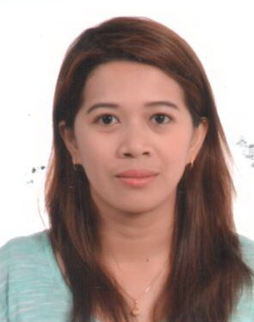

AGNES
AGNES.332553@2freemail.com

OBJECTIVE:
To obtain a job, enabling me to utilize my skills and develop career progression and to be able to apply my knowledge, skills abilities and experiences that could help my company in obtaining sets goals. I am hardworking trustworthy and willing to fulfill company requirements.

RELEVANT SKILLS:
- Relate well to people from variety of cultures and socio-economic conditions.
- Dedicated to work
- Disciplined, well-organized and goal oriented.
- Computer literate
- Hardworking
- God fearing.
WORK EXPERIENCE:

FRONT OFFICE DESK STAFF
NAGA LAND HOTEL
Panganiban Drive Naga City Philippines
May 15, 2007 – March 15, 2008

- Receives and direct incoming call in a professional and courteous manner.
- Prepares timecard and distributes them to appropriate departments.
- Orders supplies in accordance with procedures and budget allocations;
- Compiles reports and types general or technical materials.
- Maintains current list of customers by name and room number, list of telephone numbers for all personnel, list of departments.
- Provide guest with directions the hotel.
- Keeping the reception area tidy.
- Performs other duties requested.

SCHOOL CLERK
SAGNAY SOUTHEASTERN HIGH SCHOOL
Turage, Sagnay, Camarines Sur Philippines
June 5,2008 - January 30, 2010

- Acts in a professional manner and assumes responsibility for the total school program, its safety and good order.
- Attended various seminar, conference and training.
- Proposed and executed various project and activities for the students, teacher’s educational growth and experience.
- Maintaining the records of the students.
- Communicates with the School Head regarding the status of inventory and supplies.
- Perform basic bookkeeping, filling and clerical duties.

RECEPTIONIST
UHY SAXENA CHARTERED ACCOUNTANT
February 16, 2010 March 2015
MAZAYA BUSINESS AVENUE
JUMIERAH LAKE TOWER
DUBAI, UAE

- Answering phone calls with polite manners.
- Handling multiple tasks simultaneously.
- Provides information by answering questions and requests.
- Use computer word processing, spreadsheet, and database software to prepare reports, memos and documents.
- Sort incoming mail, faxes, mail and courier parcels.
- Forward incoming general e-mails to the appropriate staff member.
- Provided secretarial and administrative support to management and other staff.
- Make travel, meeting and other arrangements for staff.
- Coordinate the maintenance of office equipment.
- Receiving of documents regarding worker’s concern.

EDUCATIONAL BACKGROUND:

COMPUTER SOFTWARE DEVELOPMENT - Diploma
WRI COMPUTER COLLEGE
Goa, Camarines Sur
April, 2005

PERSONAL DATA:
Nationality Filipino
Date of Birth December 18, 1987
Place of Birth Sibaguan, Sagnay, Camarines Sur
Language English & Tagalog
Visa status Tourist - Visa

I hereby confirm that the information contained herein is true and correct to the best of my knowledge and belief.

