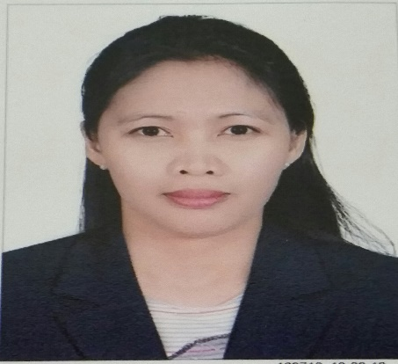
ROSSANA
ROSSANA.332558@2freemail.com

OBJECTIVE:
To be able to join in a company that will enhance my knowledge and skill through professional growth.

EMPLOYMENT BACKGROUND
Isettan Supermarket Feb. – June 2003
Araneta Ave., Cubao Quezon City
Encoder

Cherry Foodarama Supermarket March – Jan. 2003
Congressional Ave., Quezon City
Cashier/Costumer Service

Jollibee Corp. Nov. – Feb. 2002
East Avenue, Quezon City
Counter Crew

Compex.Com Feb. – July 2001
Robinsons Galleria, Ortigas
Cashier/Sales Clerk

SM Homeworld Corp. July – Dec. 2000
SM North Edsa, Quezon City
Invoicer

EDUCATIONAL ATTAINMENT

College Education

School: AMA Computer Learning Center
Course: Computer Secretarial
School Year: 1998 – 2000

Secondary Education

School: SAUYO High School
School Year: 1994 – 1998

Primary Education

School: Pasong Tamo Elementary School
School Year: 1988 - 1994

PERSONAL INFORMATION

Age: 35 years old
Date of Birth: November 22,1981
Place of Birth: Silay City, Negros Occidental
Status: Married
Nationality: Filipino
Visa: Husband Visa
License: UAE Drivers License

