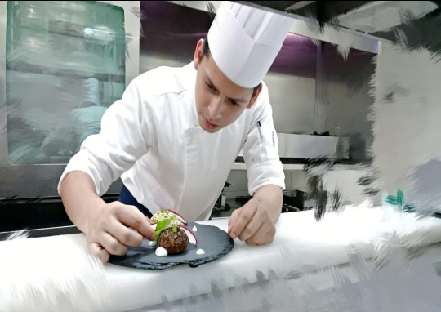
TABISH SHAIKH – CV No. 1995426

Career Objective

What counts is not the number of hours we put in but how much we put in the hours. I don’t work miracles but I work ‘HARD’ and for this I want to polish my talents for a fantastic dream to come ‘TRUE’

Preferred Area of Employment: Food Production

Cold kitchen and hot kitchen for Continental, Arabic and Indian Cuisine

Industrial Exposure

23rdApril 2014 till date Working in Dubai (U.A.E) joined as Commi 1 and promoted to Demi chef de partie. On 6th January 2015.

7th Feb 2013 to 15th Feb 2014 Working With Arjaan by Rotana Dubai (U.A.E.) as Commi 2

20th May 2012 to 10th Jan 2013 Working With sun and sand hotel Mumbai (India) Commi 2

Novotel Mumbai Juhu Beach (6 month industrial Training)
- Food Production (2 months)
- Housekeeping (1 ½ months)
- Front Office (1 ½ months)
- F & B service (2 weeks)

Current job description as Demi chef de partie.

- Maintain the highest possible hygiene and maintenance standards in your Kitchen section
- Achieve the highest degree in applied hygiene and food safety as per the ADFCA, HACCP guidelines to ensure that the food served to the Guest is of highest quality and standard
- Support directly the Chef de Parties in the daily operation and take full responsibilities of my section and tasks assigned by my immediate supervisor
- Ensure food prepared is according to the set menu specifications (pictures or/and portions) thus maintaining high standards set by the Outlet Chef
- Organize my section according to the plan device by the Outlet Chef, in order to ensure smooth operation
- Practice economy of inventory items to ensure sufficient supplies and minimize cost by avoiding wastage and spoilages
- Operate in a safe and environmentally friendly way to protect guests’ and employees’ health and safety, as well as protect and conserve the environment
- Comply with the hotel environmental, health and safety policies and procedures
- Do store ordering, managing dry stores and market items received.
- Distribute work within commi chefs and take care if it is done on time and according to standards.

Academic Qualifications

- Third Year Bachelor of Science (HOSPITALITY STUDIES)
Secured 1ST Class- 2011-2012

- Second Year Bachelor of Science (HOSPITALITY STUDIES)
Secured 1ST Class- 2010-2011

- First Year Bachelor of Science (HOSPITALITY STUDIES)
Secured 1ST Class- 2009-2010

- H.S.C.-(commerce)
Secured 2ND Class 2008-2009

- S.S.C.
Secured 1ST Class 2006-2007

Achievements

- Promoted as demi chef de partie in somewhere hotel.
- Achieved HABC level 2 award in food safety in catering (QCF) 2014
- Achieved HABC level 2 award in food safety in catering (QCF) 2013
- Awarded First Prize In Food Production Competition (Sizzle With Sizzler) At Hospitality 2012 Inter-Collegiate Competition Organised By Rizvi College Of Hotel Management.
- Awarded Over All Winner At Hospitality 2012 Inter-Collegiate Competition Organised By Rizvi College Of Hotel Management.
- Awarded Overall Best Industrial Trainee By Novotel, Mumbai ,Juhu Beach 2010-2011
- Awarded Appreciation Letter For Culinary By Novotel, Mumbai ,Juhu Beach.2010-2011
- Awarded Appreciation Letter For Housekeeping By Novotel, Mumbai, Juhu Beach. 2010-2011
- Awarded Best Industrial Trainee With The Highest Attendence By Novotel, Mumbai , Juhu Beach.2010-2011
- Awarded with 100% attendence in college. 2010-2011
- Worked In Food Production Department At Magn-2k10(College Theme).2010-2011

Hobbies:-

Boxing, Swimming& Cooking Delicious Food

Personal Details

Birth Date & Place : 19thAugust 1991, Mumbai.
Height & Weight : 160Cms& 60Kgs
Nationality : Indian
Language Proficiency : English & Hindi.

TABISH SHAIKH DATE: __________

TABISH SHAIKH – CV No. 1995426

To interview this candidate, please send your company name, vacancy and salary offered details along with this or other CV Reference Numbers that you may have short listed from
http://www.gulfjobseeker.com/employer/cvdatabasepaid.php
addressing to HR Consultant on cvcontacts@gulfjobseekers.com

We will contact the candidates to ensure their availability for your vacancy and send you our service HR Consulting Fees quotation for your approval. Whatsapp +971504753686

______________________________________

