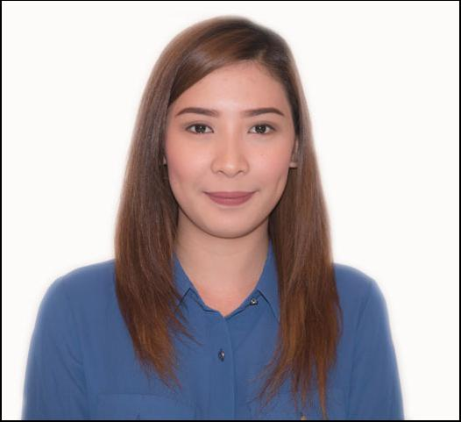
CARISSA

Carissa.332576@2freemail.com

Personal Summary

A self-motivated, results-driven salesperson having excellent communication skills, deep understanding of customer needs, and utilizes effective sales methodologies acquired through extensive experience in the retail sector.

Currently looking for an opportunity to work with a stable, culturally diverse, and constantly growing institution to employ skills as a well-rounded salesperson for the benefit of the company.

Employment History

Executive Optical (EO)

SM City Fairview, Quezon City, Philippines

SM City Valenzuela, Philippines

Sales Staff - August 2011 to February 2014

Duties and Responsibilities

- Assisting customers and patients in identifying and choosing the right products and services specific to their needs

- Served as cashier - receiving incoming sales transactions (cash or card) and handling of in-store petty cash

- Encoding and updating of previous and recent patient information using proprietary company software

- Served as stock clerk - monitors in-store product inventory, oversees product deliveries, handles mall delivery permits.

George Optical

SM City North EDSA, Quezon City, Philippines

Optical Consultant - January to April 2015

Duties and Responsibilities

- Provides sales consultancy services to walk-in customers and patients

- Oversees sales transactions (cash or card) as cashier

- Handles updating and encoding of patient records

Shapes (Apparel)

SM City Fairview, Quezon City, Philippines

Sales Staff - January to June 2011

Asia Weinet (Online Gaming)

Makati City, Philippines

Pitboss/Casino Supervisor (May 2015 to December 2016)

Education

STI College Fairview

Bachelor of Science in Business Management Major in Operations - 2011 to 2013*

*Undergraduate 2nd Year, 2nd Semester

F.G Calderon Integrated High School

Manila Philippines (2006-2010)

Lapu-Lapu Elementary School

Manila Philippines (2000-2006)

Skills

- MS Office Suite (Excel, Word, Powerpoint, Outlook)

- Operates Automatic Refractometer

Languages

•English

•Filipino

Personal Information

Date of Birth:

Nationality:

Civil Status:

February 26,1993

Filipino

Single

Visa Status:

Tourist (valid until March 2017)

