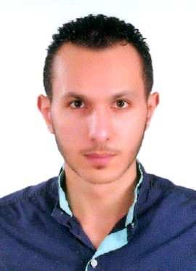
Khaled

Email: Khaled.332592@2freemail.com

Career Objectives

To obtain an accounting position where I will be able to contribute my skill, knowledge and experience to a company that will give me an opportunity to develop my career.

Work Experience | Trainee Accountant "experience certificate”  International Group of Accountant & Management – Damietta (Egypt) (Dec 2011 to Dec 2012) Responsibilities: Recording daily entries, Analysis financial lists and make Excel sheets.
Technical Skills | Most of my technical skills gained by self-study and training courses:  - Accountant Standards -FASB-  - Reports and Statements -FAR-  - Cost Accounting  - Financial analysis  - Electronic Accounting  - Accounting by Excel  - Peachtree  - Quick Books
Personal Skills | I'm always keen on improving my personal skills, and I am :  - Giving attention to details.  - Thrill in working at social environment  - Good communications skills.  - Passionate of knowledge and learning when it comes about accounting and numbers  - Good with math, puzzles and IQ.  - My English language is good and acceptable.
Education | Bachelor Degree  Damietta University (May 2013), Bachelor of Commerce, Department of Accounting "Program of study in English"
Training Courses | International Accounting Driving License "attendance certificate” John Hever Academy (2013)  Professional Future Accountant "attendance certificate”  John Hever Academy (2012)  Professional Future Accountant "attendance certificate”  International Group for Accountant & Management (2012)
Personal Info | Age : 24
Military services : Finished (2015)

