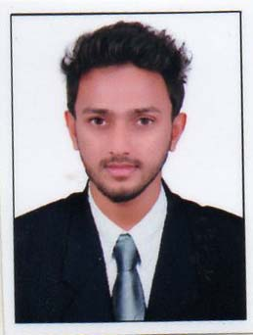  Personal Data  Date of Birth :17/07/1992  Sex : Male  Nationality : Indian  Marital Status: Single.  Religion : Islam  Passport Details  Expires : 13.08.2023  Issued : Malappuram | Muhammed  Email:- Muhammed.332597@2freemail.com  Objective.  Seeking a position to utilize my skills and abilities in an industry that offer professional growth while being resourceful, innovative and flexible. To work in firm with a professional work driven environment where I can utilize and apply my knowledge and skills to further my career goals.  Academic Qualifications.  - MBA (with specialization in Human Resource )  University : Jawaharlal Nehru Technological University, Hyderabad  Year : 2013-2015  CGPA/Grade : 75%  - B.com (with specialization in Co-operation)  University : University of Calicut, Kerala  (Hikamiyya Arts & Science College)  Year : 2013  CGPA/Grade: 2.96 (74%)  - Plus Two (Commerce with Political Science)  Authority : Board of Higher secondary Examination, Govt.of Kerala  (GHSS,Pullengode, Malappuram)  Year : 2010  Grade : 64 %  - SSLC  Authority : General education Department, Kerala  (C.H.S.S Adakkakundu, Malappuram)  Year : 2008  Grade : 70 %  Profile  - Worked in a leading furniture group as a HR Executive and Customer Relation Manager from March-2016 to December 2016, this situated in Malappuram District, Kerala.  Projects  - Title: Payroll System in ICICI Bank.  Duration: 45 Days  - Title: Role of Kudumbashree in Thiruvali Grama Panchayath  Duration: 30 days  Software proficiency / additional qualifications  - Familiar in Tally ERP 9  - Familiar with Microsoft Windows operating systems  - Excellent in MS office tools  Strength  - Confidence and Hardworking.  - Knowledge on :-  - English  - Malayalam  - Arbaic & Hindi (To read and write)  - Commitment to the t ask & fast learner  - Eager to learn new things.  - Positive approach.  - Adaptability  Achievements  Participated in national level competition THE BIG LEAP- A live marketing challenge conducted by PHILIPS. The competition has 6 rounds starting with market research to sustenance. In each round, various marketing techniques were used to introduce the new product and maintaining relationship with customer. We are achieved top 6 out of 10 qualifiers. It gave us live experience and learned marketing skills with this competition  Declaration  I hereby acknowledge that the information given above is true to the best of my knowledge and belief.  Place:  Date :

