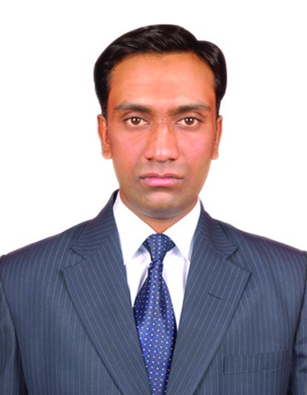
MOHAMMED TAJ UDDIN- CV No. 1995822

Professional Profile

I am an experienced and professional Administration Assistant with exceptional communication skills and impeccable presentation. A diligent and motivated worker with strong organisational skills and attention to detail, I seek a flexible role with a dynamic organisation while I complete my university studies.

Education

- MCA: Master of Computer Application from Osmania University in 2011.
- B.Sc: Bachelor of Science from Osmania University in 2007.
- INTER Vocational from Board of Intermediate Education in 2004.
- SSC: standard from Board of Secondary Education in 2002.

Employment History

Administrative Assistant December 2011 – Present

Responsible for providing an efficient and professional administrative and clerical service to colleagues, managers and supervisors to facilitate the efficient operation of the office.

- Providing secretarial services such as minute taking, WP and diary management.
- Ensuring office procedures and systems operate efficiently.
- Handling requests for information and data.
- Setting up e-mail groups for committees.
- Circulating documents via post and email.
- Scanning and copying contracts, notes and other documents.
- Checking stationary levels and ordering new supplies.
- Opening, dating, copying and circulating incoming post.
- Raising purchase orders and chasing outstanding accounts.
- Recording, compiling, transcribing and distributing the minutes of meetings

Technical Skills

- Microsoft Office
- Typing speed: 30 wpm, 95% accuracy
- Windows Operating Systems
- Hardware and Networking
- Internet Concepts

Key Skills

Areas of Expertise

- Office procedures
- Data management
- IT skills
- Customer service
- Reception support
- Diary management
- Minute taking
- Filing / archiving

Qualities and Strength

- Easily adopt new ambience.
- Keen observer new technologies.
- Ability to work under pressure.
- Positive thinker.

Passport Details

Issue Date : 20/12/2012
Expiry Date : 19/12/2022
Visa Status : Visit Visa (Valid till 6th Feb 2017)

Personal Information

- City: HYDERABAD
- Pin code: 500053.
- State: TELANGANA.
- Country: INDIA.

Declaration

I hereby give affirmation that the above information furnished by me is correct and includes all the personal and professional details.

MOHAMMED TAJ UDDIN.

MOHAMMED TAJ UDDIN- CV No. 1995822

To interview this candidate, please send your company name, vacancy and salary offered details along with this or other CV Reference Numbers that you may have short listed from
http://www.gulfjobseeker.com/employer/cvdatabasepaid.php
addressing to HR Consultant on cvcontacts@gulfjobseekers.com

We will contact the candidates to ensure their availability for your vacancy and send you our service HR Consulting Fees quotation for your approval. Whatsapp +971504753686

______________________________________

