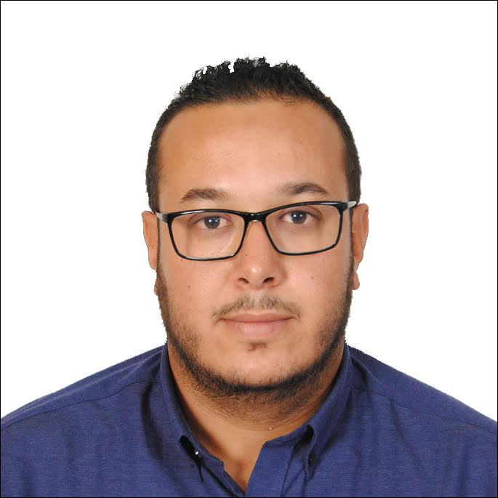

Azraida
Azraida.332651@2freemail.com

Personal statement

A highly motivated, confident sales representative with exceptional multi-tasking and organisational skills. Having extensive experience of identifying the needs of corporate customers and of running and delivering sales and marketing campaigns for key clients. Possessing a significant record of achievement in relation management and able to quickly understand the mission, vision and values of an organisation. Now looking for a new and challenging Sales representative or consultancy position, one which will make best use of my existing skills and experience and also further my personal and professional development

Key Skills

- Proficiency in all areas of Microsoft Office, including Access, Excel, Word and PowerPoint, MsProject
- Excellent communication skills, both written and verbal
- Special events organizational skills
- Skilled in computer software Autocad and Matlab

Employment History

Sales Assistant Manager, LAREGIE. LLC, Morocco
(February 2015 – November 2016)

Achievements and responsibilities:

- Performed all internal sales functions
- Achieved annual top salesperson award
- Deliver presentations and demonstrations
- Negotiate and implement pricing
- Draw up sales contracts and leases
- Provide product training
- Manage existing customer data base
- Participate in trade shows and industry conventions
- Create marketing communications
- Maintain detailed customer data base
- Meet sales targets of every monthly

Sales Executive, SADITECH. LLC, Morocco
(Aug 2014 – January 2015)

Achievements and responsibilities:

- Presenting a professional and friendly first impression of the firm to all visitors and clients
- Collaborate closely with the VP of Sales to identify regional accounts and execute the plan to call on the accounts in a timely manner.
- Deliver presentations and demonstrations
- Negotiate and implement pricing
- Draw up sales contracts and leases
- Provide product training
- Participate in trade shows and industry conventions
- Create marketing communications mainly social media
- Maintain detailed customer database
- Meet sales targets of every monthly

Education

Engineering Diploma in Automation industrial IT/ EMSI Institute,Morocco
(September 2009 – July 2014)
Bachelor Degree in Experimental Science/ Abu Chouaib Doukali School, Morocco
(September 2006 – June 2009)

Hobbies & Interests

I am involved in a local amateur dramatics society, where I volunteer as a lighting and sound technician. I have been involved with this society for three years and very much enjoy being part of the team. More recently, I assumed the role of Stage Manager for a two week production and relished the chance to take control of performances and react to a high-pressure environment.

Language

Arab: fluent French: fluent English: very good

