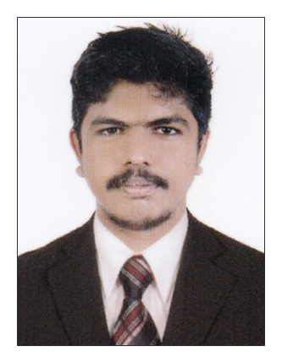  Personal Data  Date of Birth :29/11/1992  Gender : Male  Nationality : Indian  Marital Status : Single  Language Proficiency  English  Malayalam  Hindi  Tamil  Passport Details  Date of issue:13/08/2014  Date of expiry:12/08/2024  (CURRENTLY ON VISIT VISA)  Personal Traits  - Positive attitude and willingness to take responsibilities.  - Confident, Hard work, Keen observer and optimistic.  - Possess pleasant manners  Personal Qualities  - Good interpersonal and communication skills.  - Able to work to a schedule and meet deadlines.  - Able to remain calm and confident under pressure.  - Problem solving.  - A quick learner of new designs and drawings.  - Ensuring safety and Quality norms as per standards and completion within time. | Curriculum Vitae  Rajeev  Email: rajeev.332656@2freemail.com  Career Objective  To secure a full-time position in Mechanical Engineering, where I can apply my technical and personal skills and contribute to grow together with the progressive organization.  Post Applied for  MECHANICAL ENGINEER  Professional Summary :  Worked with as HVAC ENGINEER From 06/07/2014 to 30/09/2016  (Currently in UAE)  Roles &Responsibilities.  - Assist the commissioning team in pre-commisioning and commissioning stages of all HVAC equipments.  - Get approved HVAC shop drawings, work method statement and project specification from project engineer.  - Preparing relevant documents to conduct inspection for completed installation activities.  - Carry out all planned site inspections as per the intervention points marked in the relevant drawing and standard.  - Assist the project engineer during preparation of final test reports, as built drawings, operation and maintenance manual the project to client.  Academic Credential  Proffesional  - B.E. in Mechanical Engineering completed from Anna University in Maharaja Engineering College, Avinashi, Tamilnadu, India. 2010 to 2014.  Educational  - Higher Secondary-2 year course from Kerala State Educational Board, India, with 73%marks.  - Secondary School Leaving Certificate conducted by Kerala State Education Board, India. With 92% marks.  Specialization  - QA/QC Engineering course from IIS institute, cochin.  - Pipeline Engineering from IIS institute, cochin.  - NDT Level-II from IIS institute, cochin.  Areas of Interest  - As a Mechanical Engineer in Oil & gas field  - As a piping/planning engineer in construction field  - As HVAC Engineer  - As a quality control engineer  - As a Production Engineer in Production Industry  - As a designing engineer  - As a safety officer  Projects and Seminars  - ANALYSING THE PERFORMANCE OF AN IC ENGINE USING NON-EDIBLE OIL BIODIESEL for main project from Maharaja Engineering College, Tamilnadu.  - Seminar conducted based on the topic EXHAUST GAS RECIRCULATION SYSTEM from Maharaja Engineering College, Tamilnadu.  - FABRICATION OF NATURAL SOLAR WATER HEATER FROM WASTE THINGS for mini project as part of syllabus from Maharaja Engineering College, Tamilnadu.  Practical skills  - Good written and interpersonal skill able to follow standard operating procedures.  - Intermediate level computer skills.  - Good manual dexterity.  Software Skills  - Basic CAD,ANSYS,PRO-E  - MS Office  - Advanced Excel
Declaration
I hereby declare that all the above details furnished by me are true to the best of my knowledge.
Yours Sincerely,
Place: ABUDHABI RAJEEV.M

