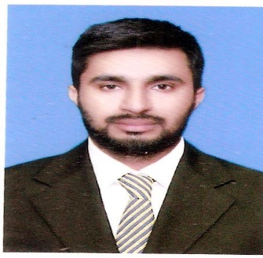
SABER
Resume
SABER.332674@2freemail.com

OBJECTIVE:
Seeking position in mission oriented organization. Offering challenging job opportunity, require creativity, motivation, Intelligence and hard work. Where I can enhance my professional skills by working with highly talented people to learn, grow and achieve something in life.
PEROSNAL INFORMATION:
- Date of Birth : 21-April-1992
- Domicile : Gujranwala
- Nationality : Pakistani
- Religion : Islam
- Gender : Male
- Marital Status : Un-Married
- Visa expiry : 16 January 2017

ACADEMIC QUALIFICATION:
Exam | Year | Marks /CGPA | SUBJECTS | Board / University
BACHELOR IN BUSINESS ADMINISTRATION | 2016 | 2.5 | MARKETING | UNIVERSTY OF GUJRAT
DEPLOMA IN COMMERCE | 2011 | 1200/685 | ACCOUNTING | PUNJAB BOARD TECHNICAL EDUCATION LAHORE
MATRIC | 2009 | 401/850 | SCIENCE | GUJRANWALA BOARD

Experience:

DESIGNATION | ORGANIZATION | TENURE
Marketing officer | ALDALMA (air travel agency Pakistan) | March 2014 to December 2014
Marketing Internship | The bank of Punjab (Govt bank in Pakistan) | July 2015 to September 2015

Online sales exprince:

COMPUTER AND INTERNET Marketing SKILLS:
- Strong Computer Knowledge, MS Office presentation in power point excel sheet managing data and analyzing data, word report writing.
- Camtasia studio creating and video editing for video add.
- Google addword, the biggest an advertising service and keyword finding.
- social media marketing Facebook, twitter,instagram.
- YouTube marketing online video adds.
- blogging design and development
- Search engine optimization wordpress sites and blogger to bring in to in search engine.

Certificate:

Diploma Certificate in web structure and development.

Three month diploma in English language.
- Three month diploma in computer hardware.
Achivements:
- Got second position in High jumps at collage level.
- Earned more then 20,000$ in online work.

LANGUAGES:
- English, Urdu, Write, Read & Speak.

