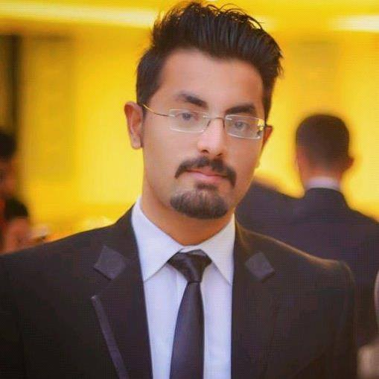

UMAIR
Personal Information:
Name: Umair
Umair.332683@2freemail.com

Objective:
To become part of a competitive, challenging and creative environment the field of Information Technology where my potential knowledge, skills and abilities be utilized for prosperity of the organization, explore in different fields and seek an opportunity for enhancing my knowledge and professional skills within a dynamic and progressive environment.

Experience:

September 2015 to October 2016

Assistant network administrator

At ArkdotNet

Location: Islamabad, Pakistan ,Chak Shahzad

Job Role: Assistant Network Administrator / Technology
worked as Assistant Network Administrator at ArkdotNet under observation of highly qualified staff and learnt a lot in that era of time.
March 2015 - September 2015
- Network & Computer Administrator (DEO)

at Al-Fareed Motors & Workshop

Location: Islamabad, Pakistan , Al-Fareed Motors Wah Cantt, Islamabad
Job Role: Networks & Computer Administrator
Worked in Al-Fareed Motors for short period of time I was assigned the role to design and modify the network present there and to maintain records of every proceedings
July 2015 to September 2015

- Internship

at Pakistan Ordanance Factories POF
Location: Pakistan ,Wah Cantt, Islamabad
Job Role: Internee
Worked as an internee in Pakistan's biggest weapon making factory and I had a chance to look Networks and other tools very closely and learnt a lot about Web Development.

- Worked as co-developer in Google play store applications.

Certification:

- Cisco Certified Network (CCNA) Trained.

Education:

- BS (Hons) in Computer Science 2011 to 2015
COMSATS institute of Information Technology, Wah Cantt, Pakistan
Securing CGPA of 2.51

- Academic H.S.S.C (Pre-Engineering):2011
FG Science Degree College Wah Cantt.
(FBISE Islamabad)
securing A Grade (59.00%)

- S.S.C: 2009
POF Model High School Wah Cantt.
(FBISE Islamabad)
securing A Grade(74.00%)

Major Subjects Taught:

- Computer Networking
- Web Development
- Web Engineering
- Programming (C, C++, Java, PHP)
- Communication skills
- Computer Organization and Assembly language
- Computer Architecture
- Software Engineering
- Data Structures and Algorithm.
- Software Project Management.
- Artificial Intelligence.
- Data Base Design
- Enterprises Resources.

Software and Tools Proficiency:

- Basics of Android Programming
- Basics of HTML & CSS
- Other Programming Languages(C, C++, java)
- Programming Editors( Turbo C, Dreamweaver, Eclipse, Studio, Sublime Text Editor)
- Cisco Packet Tracer
- MS Office 2007
- Sub netting
- Routing & Switching

Awards and Honors:

- I was awarded a fully funded scholarship from Information and Communication Technology Research and Development(National ICT R & D) for BS degree.
- Participated in Visio Spark Project Exhibition 2015.
- Got paid Internship of one year from Prime Minister Internship Program 2015 on merit.
- My idea was awarded as second best idea in Artificial Intelligence expo.
.
Projects:

I have developed my final year project of BS degree Titled as “The Muslim” Based on Animations.
Tools: Unity and Cinema 4D. .

Language Proficiency:
- English: Excellent
- Urdu: Excellent (National)
- Hindi: Good

