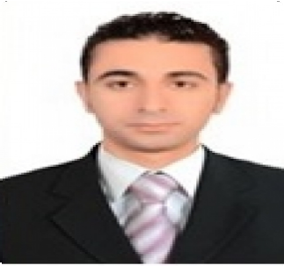Mohamed

Mohamed.332719@2freemail.com

PERSONAL SUMMARY

A bright, talented and ambitious IT support technician with a strong technical background who possesses self-discipline and the ability to work with the minimum of supervision. Having exposure to a wide range of technologies & able to play a key role in diagnosing hardware and software problems and to ensure that quality solutions meet business objectives. Possessing a good team spirit, deadline orientated and having the ability to organize and present complex solutions clearly and accurately.

Looking for a suitable IT support technician position with a successful and dynamic company that offers room for progression.

EDUCATION

      - Bachelor Of law
      - Graduated from Alexandria University
      - Year of graduate 2013

QUALIFICATIONS

- A+
- CCNA R&S (Cisco ID NO :
- CCNP R&S
- MCSA 2012
- EXCHANGE 2013

Language

Arabic: Native Language

English: Very Good

.

.

WORK EXPERIENCE

Future PC Company
HELPDESK ANALYST June 2004 - June 2005
Reporting to system administrator and collaborating closely with other IT team members. Responding to queries in a timely and accurate manner and resolving queries to the user’s satisfaction.
▪ Inrange Company
IT SUPPORT TECHNICIAN July 2005 -June 2006
Responsible for the installation and maintenance of IT equipment including (but not restricted to) printers, scanners, X -terms and workstations. Supporting customers using remote access technologies and also by visiting client sites.
- Data Link
IT SUPPORT TECHNICIAN July 2006 - June 2010

- Sets up, configures, and supports Microsoft windows operating systems, Microsoft Office suite of applications, and other windows based applications including all patch and service pack levels. Develops monitors and maintains the corporate email systems, user group security policies, and configurations. Maintains inventory of all software licensing.

- Troubleshoots network performance issues and creates and maintains a disaster recovery plan. Recommends upgrades, patches, and new applications and equipment. Provides technical support and guidance to users. Familiar with standard concepts, practices, and procedures using Microsoft operating systems, application suites and tools.
- Carrefour
IT Sales Representative July 2010 - march 2012
- Meet sales target identified by upper management.
- Develop effective sales plans.
- Help design promotional materials.
- B.TECH
IT Sales Representative march 2012 - march 2013
- An experience of selling communications, IT hardware, voice applications, broadband connections, microchips, network applications, services, data, software and cloud-based technologies.

- Extensive knowledge of the company's products and also of the wider IT marketplace. Keeping up to date with the developments of new technologies.

- Awareness of emerging markets, technologies and trends. Experience in a leadership role.
- Virus company
IT Support Engineer April 2013 - September 2016

A competent IT support Engineer with a proven track record of providing
Specialist technical and helpdesk support. Extensive experience of working in
The front line helping clients and colleagues resolve complex technical IT issues
Possessing excellent client facing skills, natural problem solving and analytical
Skills and able to contribute to the development of best practice, procedures and policies within a company.

