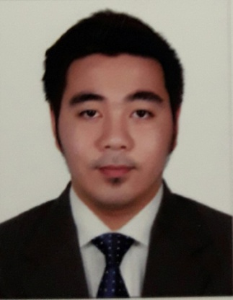

CARLO
CARLO.332766@2freemail.com
PERSONAL SUMMARY
A highly competent and enthusiastic with experience in a wide range of technologies and able to play a key role in diagnosing hardware and software problems to ensure that quality solutions meet business objectives. Extensive experience of working in the front line helping clients and colleagues resolve complex technical IT issues. Possessing a good team spirit, deadline oriented and having the ability to organize and presents complex solutions clearly and accurately.
Looking for a career advancement opportunity with a company that will challenge my problem solving skills and allow me to develop my knowledge and potential.

KEY SKILLS AND COMPETENCIES
- Highly organized and disciplined with a passion for Information Technology
- Knowledge of VISTA, XP, Windows & Microsoft Office to 2007
- Basic understanding of PC Hardware set-up and configuration
- Excellent customer facing, communication and rapport building skills
- Proficiency in the troubleshooting and resolution of all client queries
- Able to communicate complex IT issues to suppliers and non-technical staff
- Good problem solving skills along with the ability to maintain calm under pressure
- Customer focused and keen on exceeding expectation
- Having a passion for providing excellent customer service
- A positive, high energy team player

EXPERIENCE
07/2014 – 02/2016 Admin Assistant / IT Technical Support
Smart Telecommunications Co. - Makati, Manila Philippines

Responsible for the installation and maintenance of IT equipment including printers, scanners and work stations. Supporting customers using remote access technologies and also by visiting client sites.

Duties:
- Updating and monitoring IT user accounts
- Maintaining up to date Antivirus levels on all machines company wide.
- Liasing & meeting with external suppliers of IT services
- Troubleshooting PC’s, laptops, and mobile devices
- Configuring and managing backup & restore procedures
- Purchasing of IT Equipment and software
- Installation and support of telecommunication equipment
- Provide secondary support for LAN administration

06/2013 – 05/2014 Sales Associates
Guess Shop – SM City Angeles Pampanga Philippines

Duties:
- Prepares daily sales report
- Sells retail merchandise and assists customers with advice on purchase and product promotion.
- Ensures accurate checking of credit cards, cheques or any other mode of payments from the customer
- Responsible for maximizing retail sales through product knowledge, customer service and selling skills.
- Implement stock control and security procedures and maintains appropriate record as required by company policy.
- Perform an important role as an individual plus performing in a team to ensure team success of the retail showroom.

04/2012 – 02/2013 Service Crew
Gloria Jean’s Coffee Shop – N.E. Pacific Mall, Cabanatuan City Philippines

Duties:
- Greet customers always with enthusiasm
- Maintains sanitation in work area and follows operating procedures
- Ensure prompt delivery of beverages and food to the customers
- Monitor stocks and assists with the inventories and ordering of supplies
- Ensures service counters are clean all the time and filled with stocks
- Assists Baristas.

EDUCATION

Bachelors of Science in Information Technology
Nueva Ecija University of Science and Technology (NEUST)
Cabanatuan City, Philippines
2008-2012 Graduated

TRAINING

Department of Science and Technology
San Fernando Pampanga, Philippines (March 2012)
- Inventory and maintenance of computers
- Operate and maintain network services, routers, modems and other network services

PERSONAL INFO.

Birthdate: April 23, 1992
Status: Single
Visa Status: Tourist Visa

Reference available upon request.

