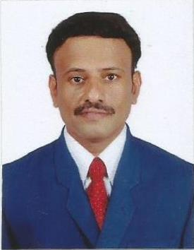
CURRICULUM VITAE

SUDHAKARAN
Al Karama, Dubai
Email Id: sudhakaran.332780@2freemail.com

OBJECTIVE:
An enthusiastic Quality Assurance professional with over 5 years of experience in medical coding and quality assurance. Have a strong background in coding techniques, guidelines, medical terminology, physiology and pharmacology. Sound knowledge of US healthcare system and Medical coding of ICD/HCPCS. Able to work on own initiative and as part of a team. Leadership skills include managing, developing and motivating team members to achieve their objectives.

PROFESSIONAL SKILLS:

- Certified Professional coder (CPC) from the American Academy of professional coders (AAPC).
- Completed the ICD 10 proficiency exam
- Completed UAE insurance guidelines training program at Hbay healthcare PVT LTD

WORK EXPERIENCE:
- Worked as senior Medical Coding Executive in Ecare pvt Ltd, chennai from Oct' 2014 to Oct' 2016 .
- Worked as a Senior Medical Coder in Pradot Technology Services Pvt Ltd., Chennai from Oct' 2013 to Jun' 2014
- Worked as a Senior Medical Coder in Lapiz online Solutions, Chennai from Jan' 2012 to Oct' 2013.
- Worked as a Medical Coder in Ajuba Healthcare, Chennai from Apr '2011 to Nov '2011.

JOB PROFILE:
- Code medical records with ICD-10, ICD-9, CPT-4 and HCPCS level II coding daily while maintaining accuracy and achieving productivity goals.
- Maintains a thorough understanding of assigned client coding specifics and performs coding duties according to pre-determined schedules.
- Coding and auditing the medical documents on various specialties of coding like ER , ED ,E&M as per client instructions and submitting the report to authority on daily basis
- Act as a mentor and coach for the team members in the healthcare organisation.

ACADEMIC QUALIFICATIONS:
- Sri Ramachandra medical college & research institute chennai – Bpharmacy
- Alagappa University –MBA

STRENGTHS:
- Ability to work in a group environment.
- Hardworking and Positive thinking.
- Ready to take challenges.

PERSONAL PROFILE:

Name : Sudhakaran
Gender : Male
Nationality : Indian
Languages known : English, Tamil & Telugu.

DECLARATION:
I hereby declare that all the information furnished above is true to the best of my knowledge and belief
.(SUDHAKARAN)

