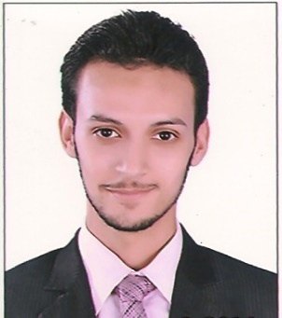
AhmeD
AhmeD.332781@2freemail.com
Information Technology

SUMMARY
To find a challenging job that would be added to my experience for managing and support diverse sets of IT technologies and systems management, seeking an opportunity to join a dynamic organization in a suitable position that is seeking to leverage my skills.

SKILLS
VMWare | Troubleshooting | Network Administration
MCITP | Cisco Technologies | HTML
CCNA | Management | Active Directory
Hardware Maintenance | Computer Science | GPS Applications
CRM | WordPress | All Windows Platform
Juniper | ITIL | TMG & Firewall servers
Dhcp | DNS | Windows Server

EXPERIENCE

Deem Al Sabah Contracting Riyadh, KSA 11 / 2015 – 07/2016

IT Manager
• Implement all strategies for all IT operations.
• Upgrade to all systems as per requirement.
• Analyze all IT infrastructures and prepare reports.
• Design and execute all IT policies and procedures to design all IT infrastructures.
• Maintain compliance to all standards and policies and administer efficient working of all IT equipment's and
hardware and manage all communication with operation management team.
• Design Network Layouts/Designs.
•Provide support to all software works and used by our company.
• Configuration of CCTV IP & Analog Cameras, DVR, NVR.
• Setup and Administration DVR Floor cameras.
• Configuring & troubleshooting Network problems.
• Planning, Design, Implementation and many things related with IT Infrastructure and IT Management.

Asset Technology Group – Cairo, Egypt 04 / 2014 – 04/2015
IT Coordinator
• Responsible for planning/execution of new projects and utilize available technical support staff and resources.
• Resolve Level 2 and 3 issues in systems and network.
• Installation and configuration of Network printers with SMB and other service support.
• Configuration of Time Attendance and Access Control.
• Preparation and implementation of Disaster Recovery Plans (DRPs) for critical services.
• Setup and Administration of centralized Antivirus System of Kaspersky.
• Monitoring Network/System operations and daily check system security and machine performance.
• Prepare daily report about GPS.

Egyptian Armed Forces | 03 / 2013 - 02 / 2014

Technical Support
- Installation/configuration.
- Operations and maintenance of systems hardware and software and related infrastructure.
- This individual participates in technical research and development to enable continuing innovation within the infrastructure.
- This individual ensures that system hardware, operating systems, software systems, and related procedures adhere to organizational values, enabling staff and Partners.

EDUCATION

BACHELOR OF Computers & Information
Major in Computer Science
Year graduate: 2012

COURSES

N+
CCNA (Cisco Certified Network Associate).
CCNP (Cisco Certified Network Professional).
MCSA (Microsoft Certified Solutions Associate ).
MCSE (Microsoft Certified Solutions Expert ).

LANGUAGE
Arabic | Native language
English | Very Good

