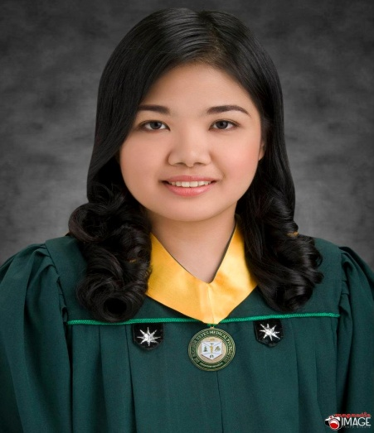

MA. CHRISTINA
CHRISTINA.332785@2freemail.com

OBJECTIVE

- Registered Medical Technologist with 7 months of experience as an Intern student at FEU-NRMF Medical Center and bachelor’s degree in Medical Technology.

- Currently Working at Marikina Valley Medical Center in the Philippines.

- 7 months of working experience as a registered medtech at Novaliches General Hospital in the Philippines

- Quality-focused medical technologist with good clinical skills gained through hands-on experience.

- Reliable, diligent and focused on the timely, quality completion of all lab procedures.

- Capable of analyzing samples of body tissue and fluids to to aid in the diagnosis and treatment of diseases.

- Ensured test-result validity before recording and reporting the results.

WORK EXPERIENCE

INTERNSHIP
9/2011-4/2012, FEU-NRMF MEDICAL CENTER , West Fairview, Quezon City
Completed 7 months internship at FEU-NRMF MEDICAL CENTER

4/2013-9/2013,NOVALICHES GENERAL HOSPITAL , Novaliches, Quezon City

WORK

4/2014 – onwards , Medical Technologist at Marikina Valley Medical Center.

Contributions:
- Collected various specimen samples .

- Operated and calibrated laboratory equipment and performed various chemical, microscopic and bacteriologic tests.

- Performed stat and routine testing on a variety of specimens quickly and accurately.

- Followed lab protocols, sanitation standards and testing procedures.

.

EDUCATION
2007-2012: Far Eastern University-NRMF, West Fairview Quezon City
- BS degree in Medical Technology
- Course Highlights: Medical Lab Practices, Organic/Biochemistry, Principles of Hematology & Hemostasis, Pathogenic Microbiology, Blood Banking, Clinical Chemistry, Clinical Microbiology, Clinical Microscopy, Immunohematology, Supervised Clinical Experience

Certification:
- Board of Certification
Medical Technologist (MT) 2012

QUALIFICATION
Performs serological, bacteriological, hematological, microbiological laboratory examinations and tests for use in treatment and diagnosis of disease.

Knowledge, Skills and Abilities:
- Knowledge of the principles, methods, materials, equipment and techniques of medical technology.
- Skill in both verbal and written communication.

