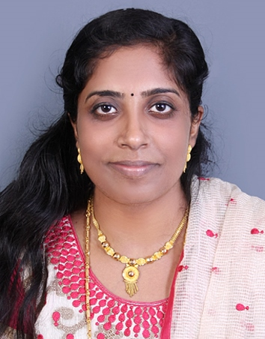
CURRICULUM VITAE

Name Miss. Issac
Email:- Issac.332811@2freemail.com

Sex Female

Date of Birth 04-12-1987

Nationality Indian

Marital Status Married

Religion Christian

Languages Known English,Arabic, Hindi, Marathi & Malayalam

Position sought Staff Nurse

Computer Literacy Basic knowledge in computer operating

Hobbies Listening music and reading

PASSPORT DETAILS:-

Date of Issue 01-10-2010
Date of Expiry 30-09-2020
Place of Issue Cochin

EDUCATIONAL QUALIFICATION

Examination Board/University Year Results
SSLC St...Joseph High 2003 46.93%
School Colaba,
Mumbai
Plus Two Elphinstone 2003-2005 50.67%
College, Fort,
Mumbai
Bachelor of Science Nirmala College of 2005-2009 lst Year — 62.23%
in Nursing Nursing Anantapur, 2"d Year — 58.54%
Andhra Pradesh 31d Year — 69%
4th Year — 71.53%

WORK EXPERIENCE

Institution Desi nation Period Department
Bhardawaj Staff Nurse 2010 Jan. to Medical &
Hospital , Noida , Nov.2010 Surgical Ward
U.P
Medanta, the Staff Nurse 2010 Nov. to 2013 Medical & Surgical
Medicity, Gurgaon, Ward
Haryana.
King fahad Staff Nurse 2014May to still Pediatric opd
specialist hospital , working
Dammam ,Saudi Arabia

EQUIPMENTS HANDLED

• Electronic BP Apparatus, Thermometer
• Monitors, Glucometer, Nebuliser
• ECG Machine, ABG Machine
• Pulse Oximeter, Laryngoscope
• Syringe Pump, Ophthalmoscope
• Defibrillator

• Ventilator, Infusion Pump
• Oxygen Flow Meters, Oxygen Cylinders
• Suction Apparatus
• B_{aying} Circuit, Ambu Bag
• Bloodwarmer

PROCEDURES ASSISTED/DONE

IV cannulation, , Cardiac monitoring, Administration of IV fluids Blood collection, Medicine administration, Urinary catheterization, Blood-transfusion, Haemoglucose test,
Nebulization, Wound dressing, bladder wash.

Range of service of the Hospital
Medical, Surgical, Orthopedic, Paediatric, Psychiatric, MICU, SICU, NICU, Operation theatre, Ophthalmology, Obstetrics, ENT, Casuality, OPD & IPD Services, Laboratory.

JOB DESCRIPTION

As a Staff Nurse I am responsible for total Nursing Care for each patients assigned

➢ Admission of patients, orientation of new patient and his family ➢ Assessment and making plans to meet the needs to the patient.
➢ Observations, recording and reporting vital signs, intake and output, secretions and excretions,
wounds etc.
D Ensure safety and good personal hygiene, positioning, suction back care maintaining, airway,
breathing, and circulation of semiconscious, coma and unconscious patients.
D Providing active and passive exercise to the patients, making rounds and implementing doctor's
orders.

➢ Administrations of medicines, including life support, catheterization, bladder wash, enema,
rylestube placement, infusion and keeps ready all emergency equipments.

➢ Giving health education to the patients, meeting physiological, spiritual and rehabilitee needs of
the patient.
➢ And in Post-Operative unit providing care like recording and reporting of vital signs, Bleeding
intake output, level of consciousness, collection of blood and urine, stool secretions and
excretions.
)=. Wound dressing oral hygiene, back care, bed bath, positioning and making ambulation. )=. Administration of IV Fluids, drugs and maintaining circulation.

➢ Providing active and passive exercise, good standard nursing care and health education.
➢ Discharge the patients according to the hospital customs and health care procedures, giving
follow up care.

DECLARATION

I hereby declare that the above mentioned particulars are true and correct to the best of my knowledge and belief.

